**Certificate of Completion**

**Mirna Barker**



**Completed**

**Sexual Harassment Prevention for Employees**

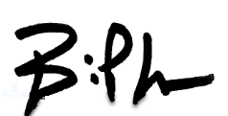

Brian Kemp

Governor

State of Georgia

Use this certificate template to create your own certificate.

1. Change the name of the employee.
2. Change the seal and include your agency’s seal.
3. Delete these instructions.