How to Make Required FLSA changes

This job aid will demonstrate how to retrieve the impacted employees file and update the FLSA status for an employee on Position data. This job aid is specific to the changes to the federal FLSA threshold. Please follow these guidelines and steps to make the appropriate data changes.
- Only change the FLSA status of employees indicated on the file from query, 0HR094_FLSA_SALARY_TEST_WRKGRP (for Time & Labor agencies) OR 0HR094_FLSA_SALARY_TEST (for non-Time & Labor agencies).
- The effective date can be any date between Nov 1 – Nov 30, 2019.
- If you receive an error message after following the steps below or the data does not update on Job, please contact Tonia Nelson.

Steps in TeamWorks:

- Navigate to Main Menu > Reporting Tools > Query > Query Viewer.
- Search for query 0HR094_FLSA_SALARY_TEST_WRKGRP or 0HR094_FLSA_SALARY_TEST. Disable any pop-up blockers on your browser.
- Click “Excel” to run the query in Excel format.

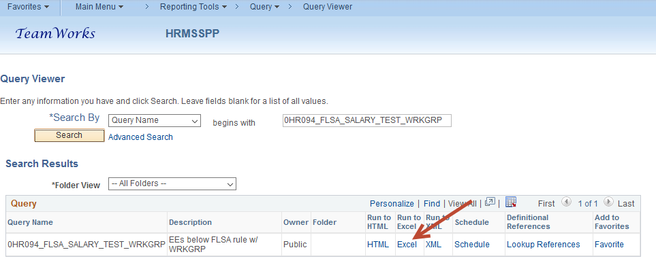

- Retrieve the data by either entering DeptID or “%”. “%” will give you all the records you have security access to view. Click “View Results”.
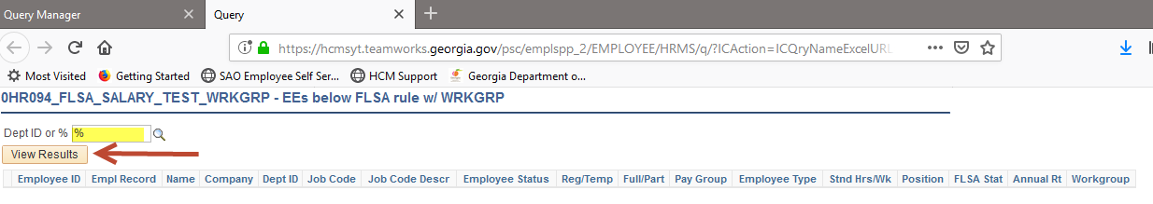

- Follow the browser directions to open/download the file.
- The file will list the impacted employees in your organization who will need their FLSA status changed.
- To make the changes on Position, navigate to Main Menu > Organizational Development > Position Management > Maintain Positions/Budgets > Add/Update Position Info.
- Enter desired position number in the Position Number field.
- Click Search.
- Confirm you are viewing the desired position/employee by checking job title, company and department.
- To add a new row, click the + (plus) symbol, under the position number.
- Enter the desired Effective Date in the Effective Date field.
- Click the symbol to search for the Reason.
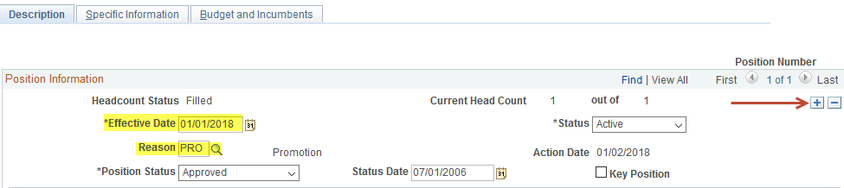

- Select CFL – Change FLSA Status
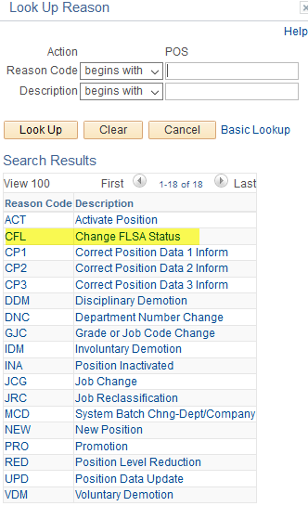

- Scroll down to the USA section of the page.
- Change the FLSA Status data field to Nonexempt.
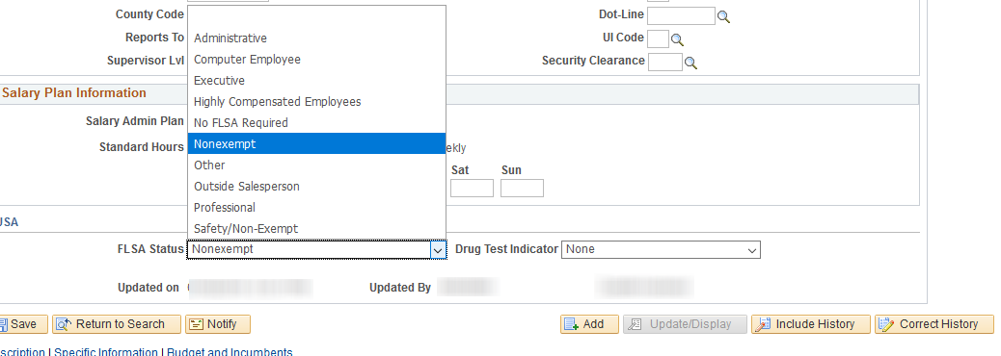

- Click SAVE.

After the position is saved, the system verifies that the fields on the Job Data page, in the Workforce Administration section, meet the following requirements:

• The position Status is Active
• The Update Incumbent box is checked
• The Override Position Data option button has not been selected for the incumbent's job data

If the requirements are met, the Update Incumbent Process is triggered. The system will capture the data from newly added Position fields on the Add/Update Position info pages. Any new data will update the corresponding matching fields on the Job Data pages in the Workforce Administration section.

Changes to any of the following fields can trigger the Update Incumbent process to run:

FTE Actual, Business Unit, Classified, Indicator, Company, Department, FSLA Status, Full or Part Time, Grade, Job Code, Location, Reg/Temp, Regulatory Region, Reports To, Salary Admin Plan, Standard Hours, Shift, Step, Union Code and Work Period

- VERY IMPORTANT - Review the employee's Job Data - Job Information page to verify that the system has made the changes.

Note: If the incumbent Job Data record has a future date (date greater than the effective date of the row entered on position), the system will not add a new row on Job Data.

- END OF STEPS

**Additional changes may need to be made to the impacted employee’s workgroup on the timesheet, if the agency is using TeamWorks Time & Labor. Please refer to the Time & Labor Operating Procedures Guide for instructions on how to make those changes.

