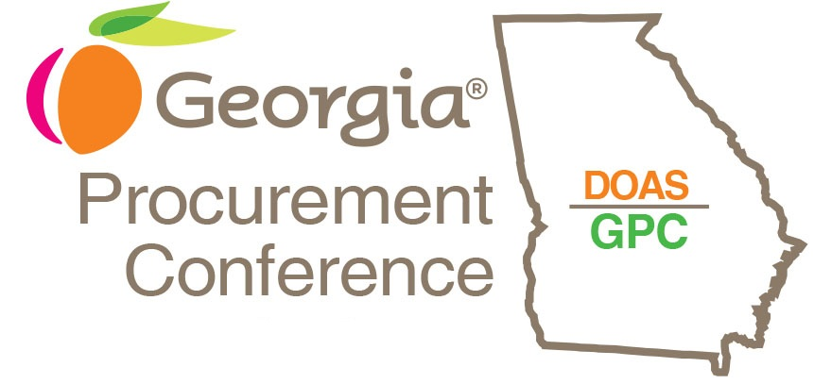

2023
Georgia Procurement Conference
Vision Awards
[Insert Name/Entity Submitting]

[Enter Submission Title Here]
[Enter Category Here]
Use this template to help guide you as you prepare your submission for review by the 2023 GPC Vision Awards Committee. It is recommended that you keep the headings as they are provided in this template. This will make it easier for committee members to review submissions. Feel free to delete the guideline text as you go through this template, it is just there to help you understand how the committee evaluates each category and does not count in your page limits.

Please review guidelines and eligibility. You can submit the completed application here. If you have questions contact gpc.info@doas.ga.gov
Application Deadline is March 3, 2023.

Executive Summary (10 points)
The evaluation consists of four criteria, each one examining a different aspect of the project's impact and each weighed separately to provide an overall score. Submissions are limited to four pages, although optional supporting material can also be submitted as a separate document when needed to showcase images, examples, or documentation that is too large to fit within the four-page submission itself. Supporting material does not weigh into the ultimate choice for winner as the judges will evaluate based on this application.
The application should begin with an introduction/executive summary that describes the purpose and scope of the project and gives a brief overview of the implementation process. The introduction should also include a summary statement of the content of each of the following three criteria and a comment on the results of the project. If there is anything in the submission to which committee members should pay particular attention, it is helpful to mention it in the introduction. This executive summary should not exceed one page and is included as part of the total pages for the submission.

Innovation (30 points)
Unusual or unique approach, scale, or magnitude of effort; conceptual originality. This category should answer the question, “What makes this project stand out as a notable contribution in state administration?” It is intended to capture the nature and impact of changes in your organization operations, but it also rewards path-breaking ideas or efforts that may not have been considered or attempted elsewhere. Because substantial originality is so rare, this category offers potential point total to a submission that can point out differences and to distinguish itself from closely similar projects completed or underway in other states.

Transferability (30 points)
Primarily an external focus that assesses the practical ability by other states to replicate or use as a benchmark, considering expected resources required and the legal or structural environment in which the entry was implemented. A project or initiative that can be used broadly by other states as a template will receive a higher score than one with benefits that appear to depend on the particular geography, environment, governmental structure or particular needs of the submitting state. In some cases, it may be necessary to explain how an apparent state-bound effort can be adapted for greater transferability.

Value Created (30 points)
An internal focus that assesses the results of the project or initiative. The results can be measured in multiple ways including actual or potential cost savings, staff time, resources, customer service enhancement or other efficiencies/value created by this initiative as defined by the submitter. More weight will be given to specific benchmarks instead of generalities. When metrics are provided, it is beneficial to include a short (non-technical) explanation of how these metrics were produced.

