 | State of Georgia Purchasing Card Program  Setting Up the Active Cardholder List in Works  P-Card Self-Assessment Instructions

Steps
- In Works, go to Reports > Create.
- Make the following selections in the Create Report screen:
  - Category: Account
  - Template: Card Status
  - Selected: Columns highlighted in the “Selected” column of Screenshot 1: Card Nickname, Card Embossed Line 1, Card Profile Name, Card Last 4 Digits, Card Profile Single Txn Limit, Card Credit Limit, Card Last Known Balance, Card Available Funds, Card Last Used, Card Create Date, Card Activation Date, Card Expire Date
  - Filter: Card Active Status, set to Yes as shown in Screenshot 1.
  - Formats: Excel, PDF, Delimited. Full Details under each section.
  - Save Template to Library: Selected
  - Template Name: Choose a meaningful name (e.g. Active Cardholders)
  - Template Description: List of Cardholders
  - Job Name: Will default to report name. You can edit this when you run it.
- Click Submit.

Screenshot 1 – Report Selections and Filters
Screenshot 1: Create Report selections and filters
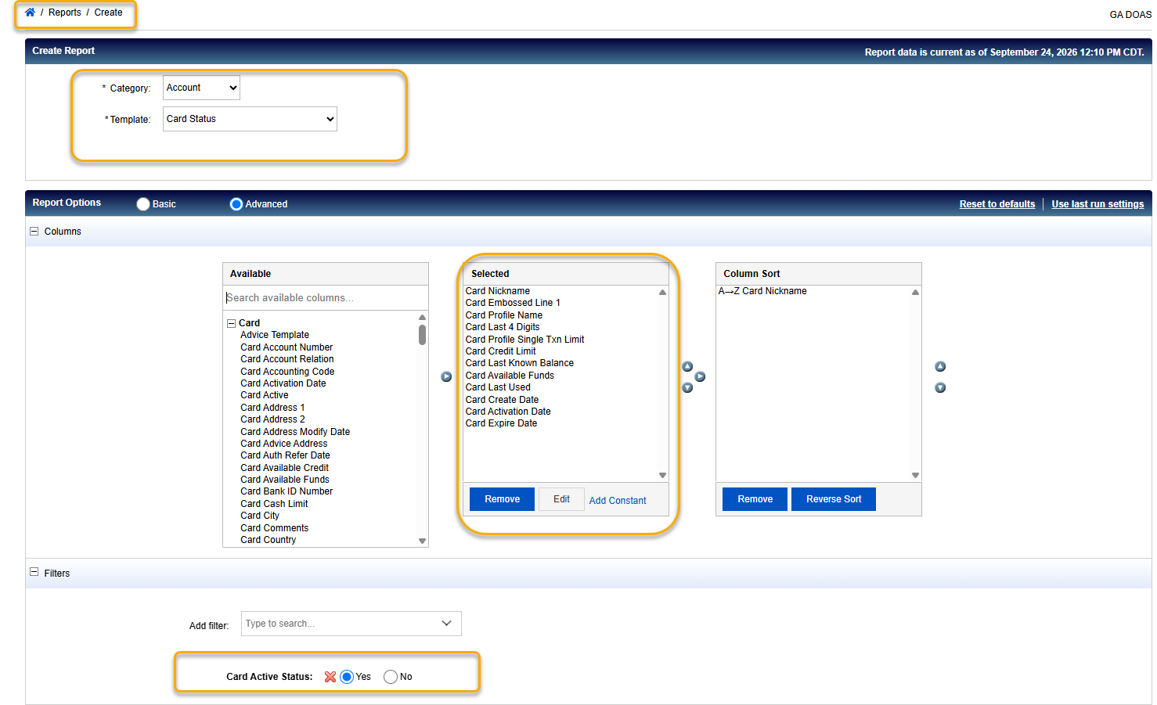

Screenshot 2 – Output Format
Screenshot 2: Output format settings
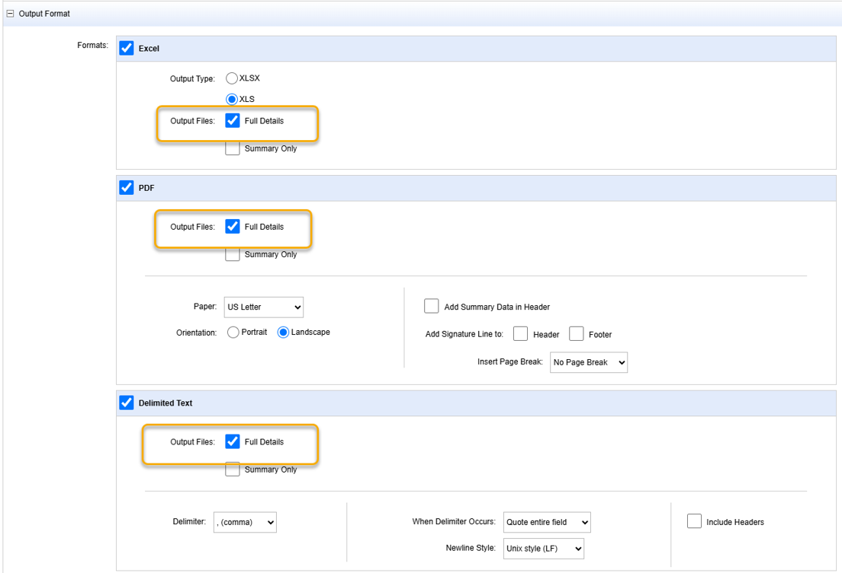

Screenshot 3 – Save Template and Submit
Screenshot 3: Save template and submit the report
