 | State of Georgia Purchasing Card Program  Setting Up the Transaction List in Works  P-Card Self-Assessment Instructions

Steps
- In Works, go to Reports > Create.
- Make the following selections in the Create Report screen:
  - Category: Spend
  - Template: Billing Statement
  - Selected: Columns highlighted in the “Selected” column of Screenshot 1: Card Nickname, Bank Number, Card Last 4 Digits, Amount, Purchase Date, Post Date, Comp Supp Name, Comp Supp City, Comp Supp State, MCC, MCC Description, Grp Name, Card Profile Single Txn Limit, Card Credit Limit, Card Status, Card Profile Name
  - Filter: Transaction Type (select the types shown): Cash advance, Misc. Credit, Misc Debit, and Purchase.
  - Post Date: Dates to be included in the report.
  - Formats: Excel, PDF, Delimited. Full Details under each section.
  - Save Template to Library: Selected
  - Template Name: Choose a meaningful name (e.g. Transaction List)
  - Template Description: List of Transactions
  - Job Name: Will default to report name. You can edit this when you run it.
- Click Submit.

Screenshot 1 – Report Selections and Filters
Screenshot 1: Create Report selections and filters
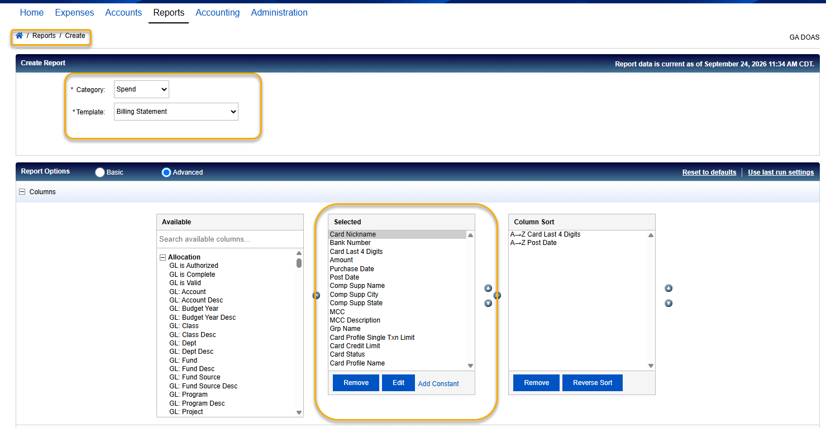
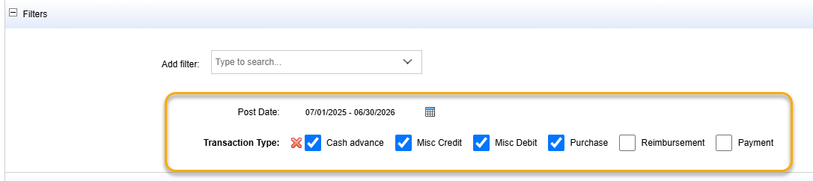

Screenshot 2 – Output Format
Screenshot 2: Output format settings
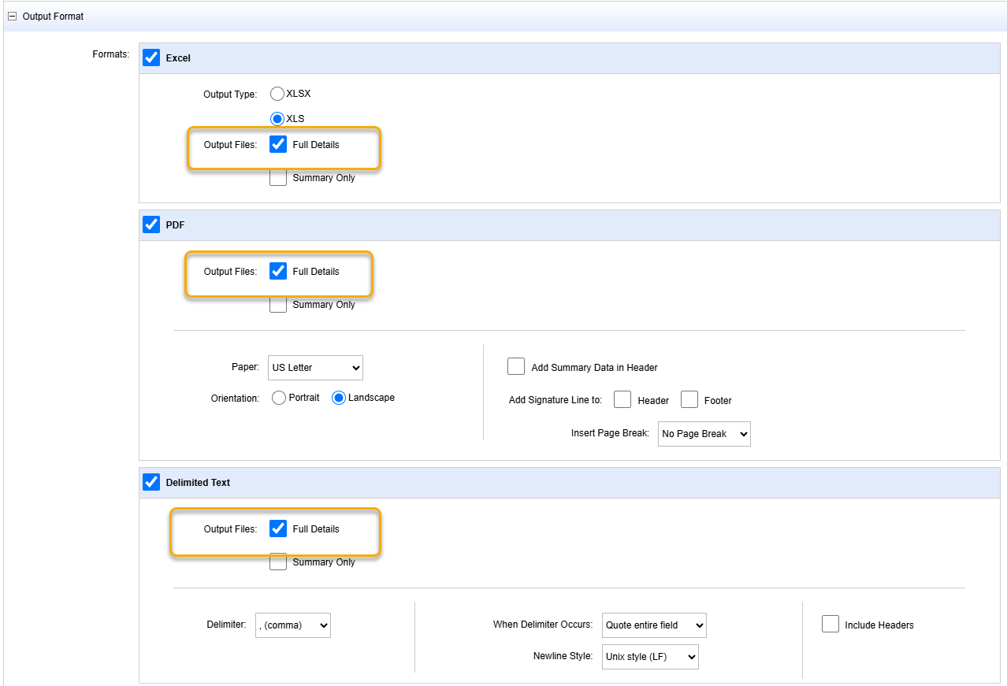

Screenshot 3 – Save Template and Submit
Screenshot 3: Save template and submit the report
