Supplier Bid Response – Buyers Attachments
Purpose: Secure Supplier portal navigation for attachments.
Supplier review of all possible places of the bid documents posted by agency sourcing buyer.
- Supplier portal  Supplier can navigate from Georgia Procurement Registry (GPR) Open Bid Search to Jaggaer Supplier Network Public Bid Search.  Supplier can click on ‘Respond Now’ button to review and submit the bid response.  Supplier can click on ‘View as PDF’ to see the detail requirements related to the event. | GPR: https://ssl.doas.state.ga.us/gpr/eventDetails?eSourceNumber=53900-eRFP-000000085-2022&sourceSystemType=jag  Jaggaer: https://bids.sciquest.com/apps/Router/PublicEvent?CustomerOrg=Georgia&tab=PHX_NAV_SourcingAllOpps&eventNumExact=53900-eRFP-000000085-2022  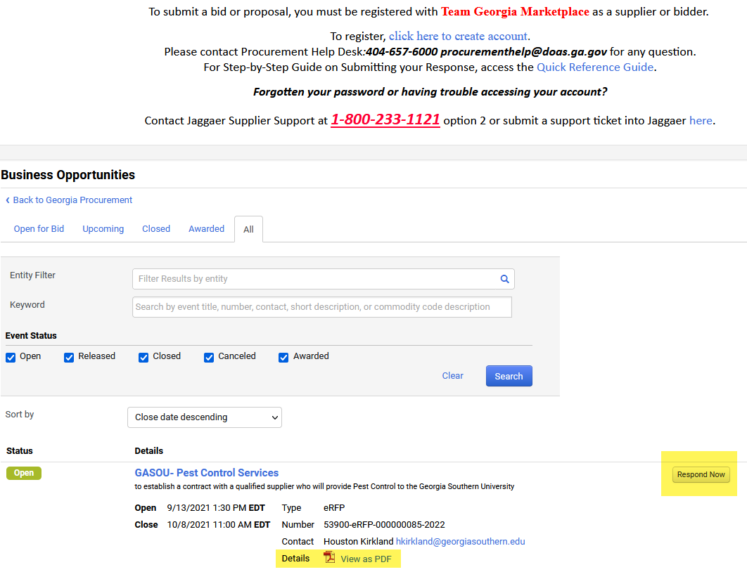

- Click on View as PDF to view Buyers Attachments section. | 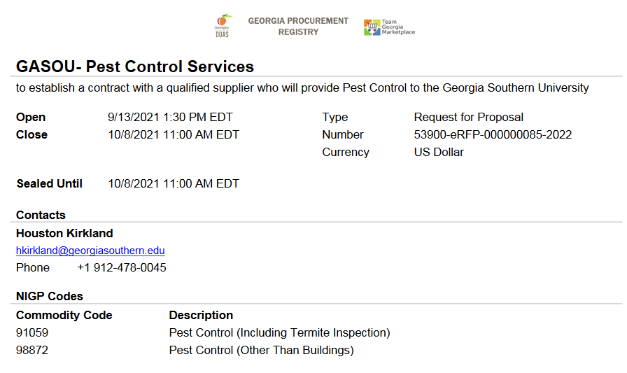  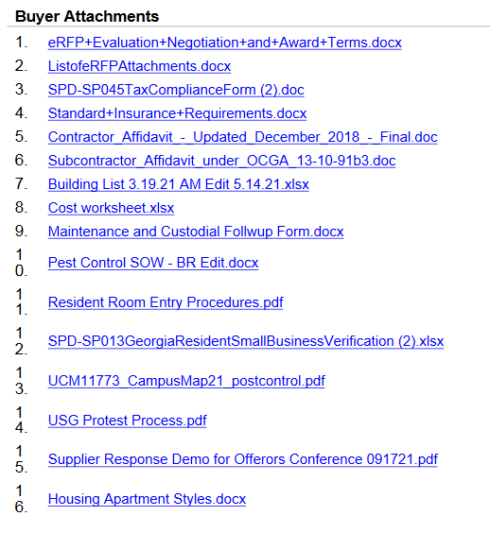

- Clicking on Respond Now which requires Supplier’s login credentials. | 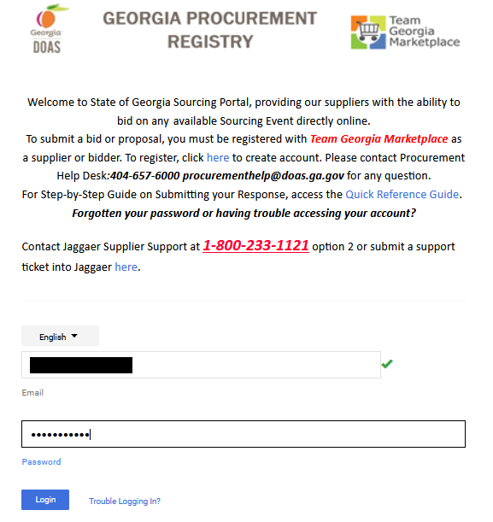
- Successful login attempt will launch supplier selected bid response page. | 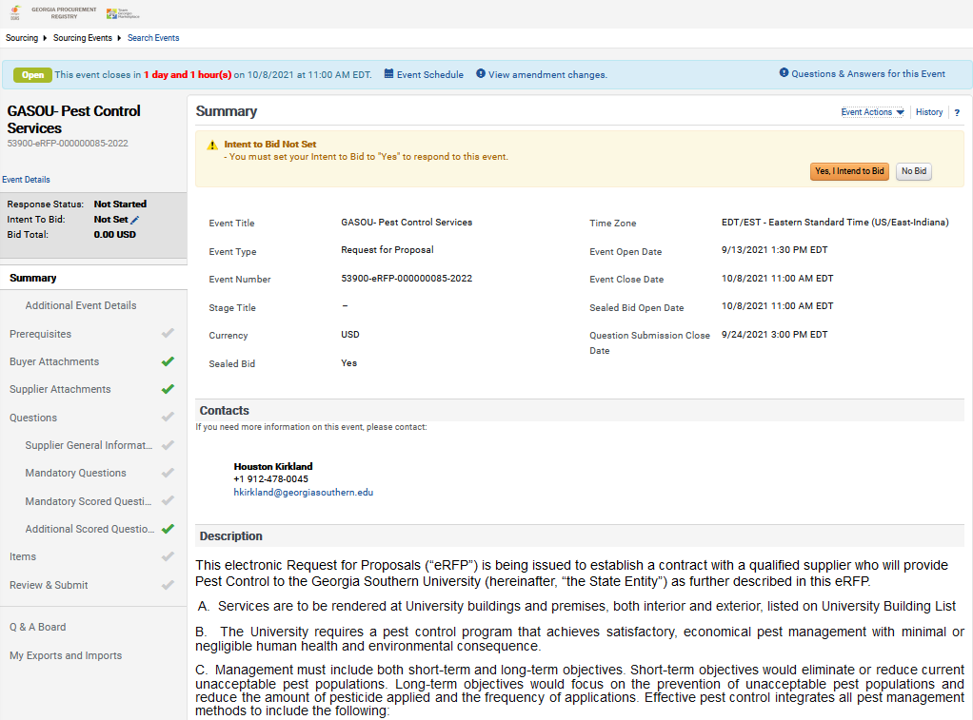

- Click on Yes, I intent to Bid to navigate within bid details and to submit bid response successfully. | 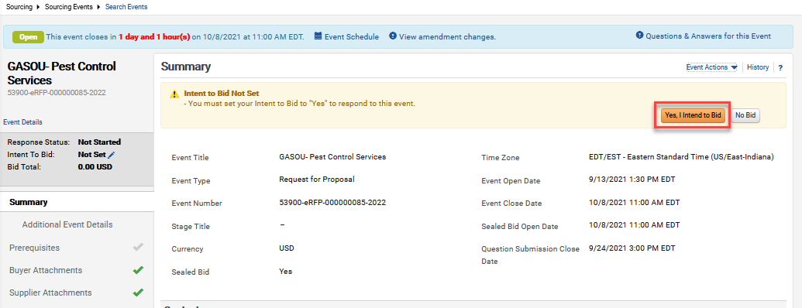
- Click on Buyer Attachments and download or open one document at a time and prepare yourself for the final bid response.  Note: The System will allow suppliers to download the attachments even without agreeing on Yes, I intent to Bid. | 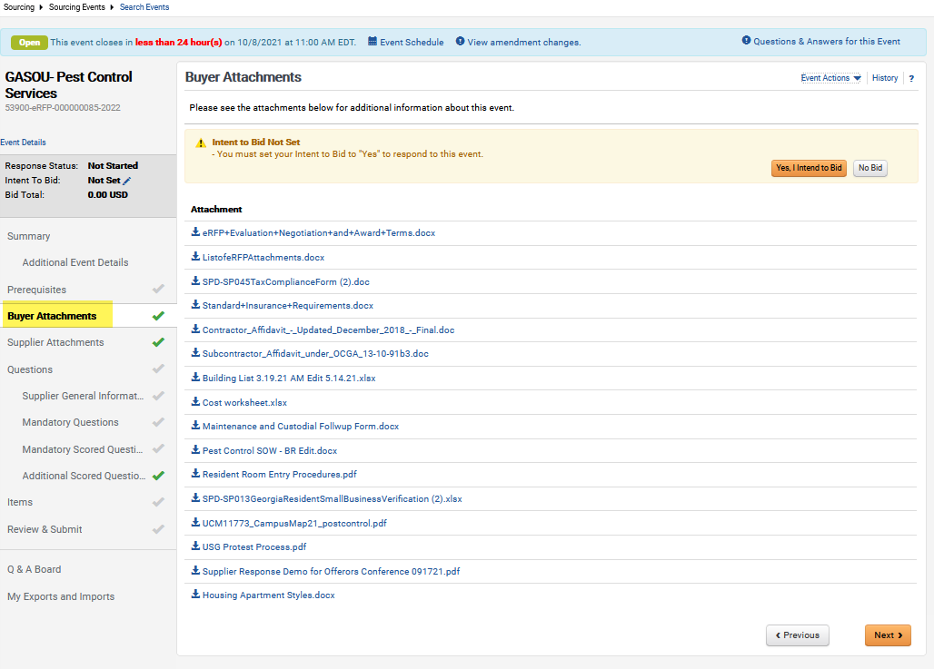

- Supplier can navigate to Questions and related area to look for attachment download symbol or option. | 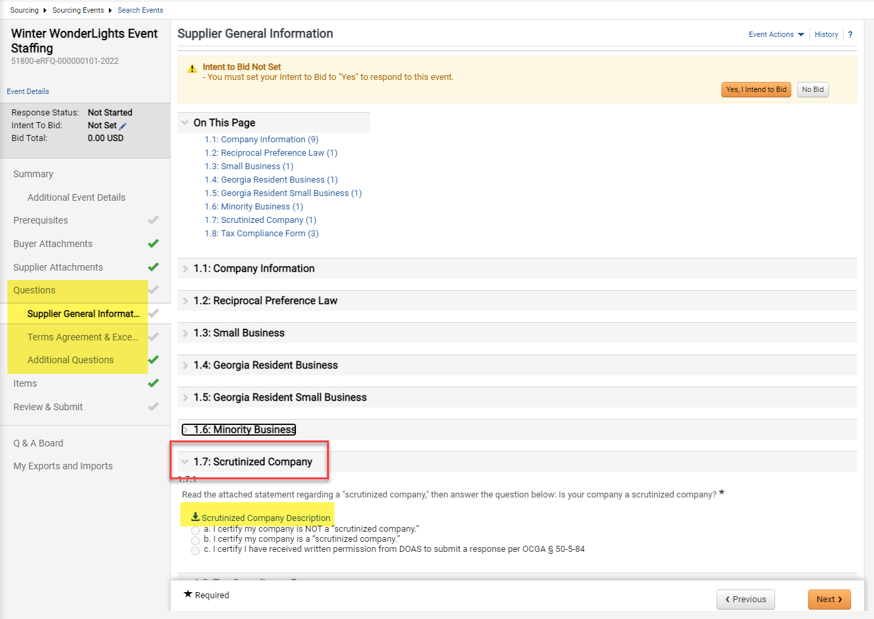  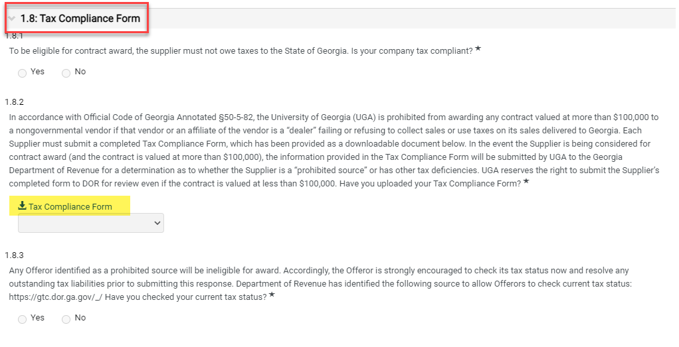  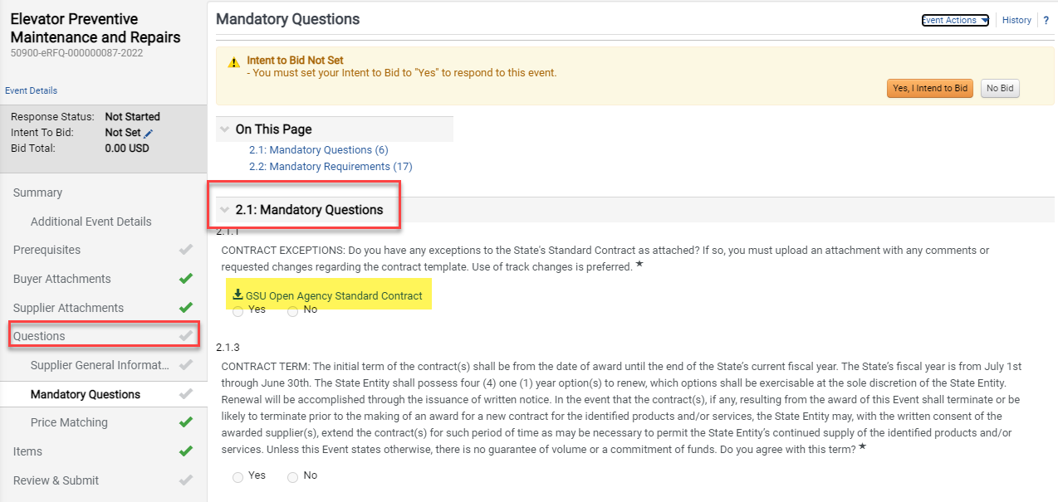

- Navigate to Q & A Board, and check for document download options if available. | 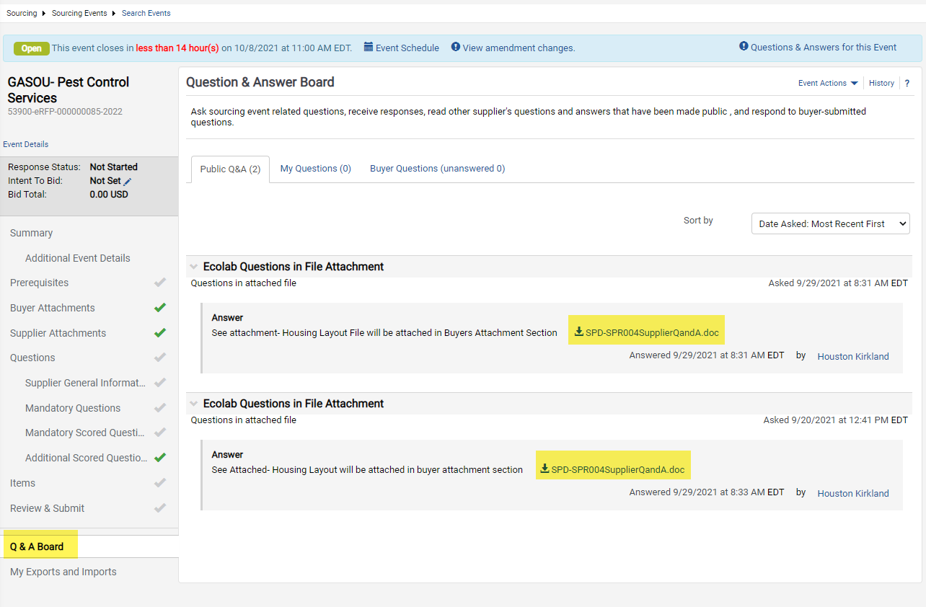
- Click on Items, Service Line Items, or Product Line Items, then click on View Details for every line item to see if the attachment is listed on the line level or not. | 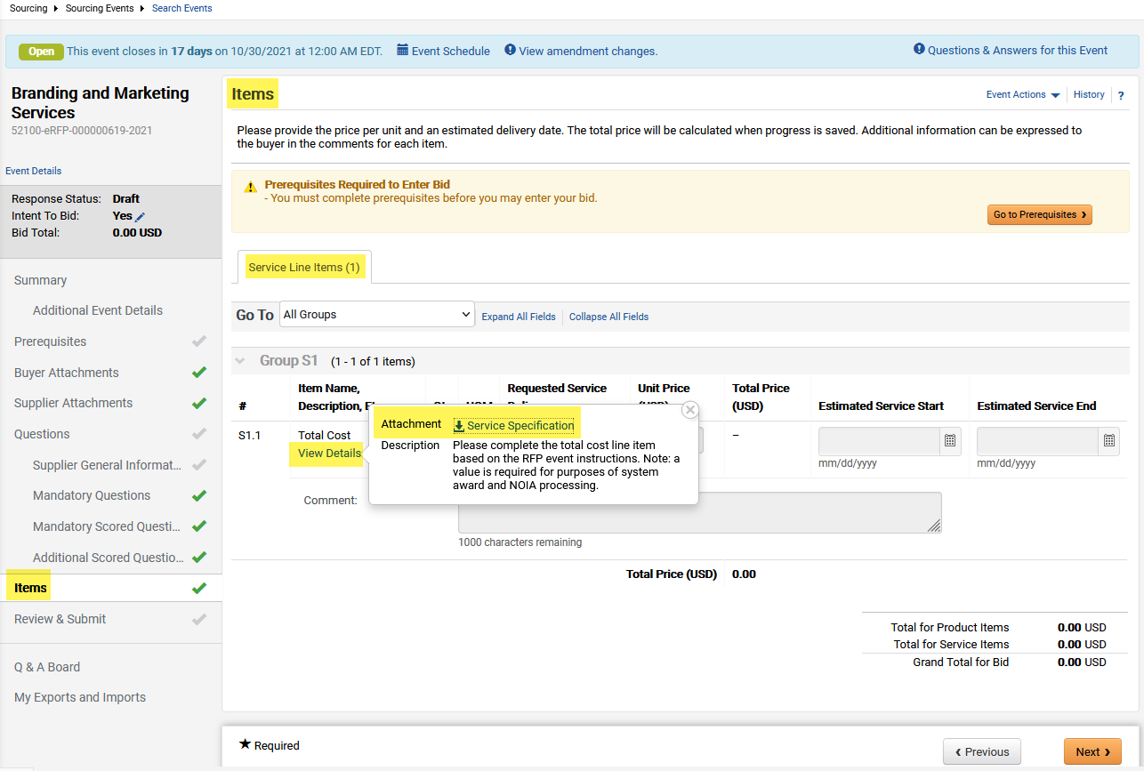
- Download all bid documents to Supplier’s local computer drive as bid response package and work towards completing and responding to bid by the set end date and time. | 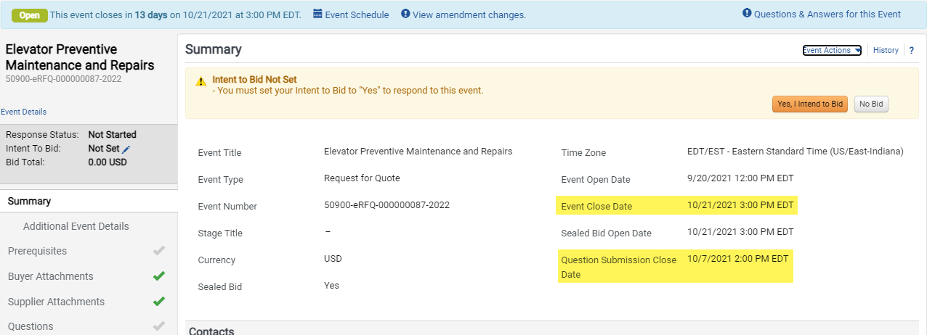

- Customer Portal Home page shows My Events with Open status, reflecting the total count of the bids where Supplier responded as Yes, I intent to Bid. | 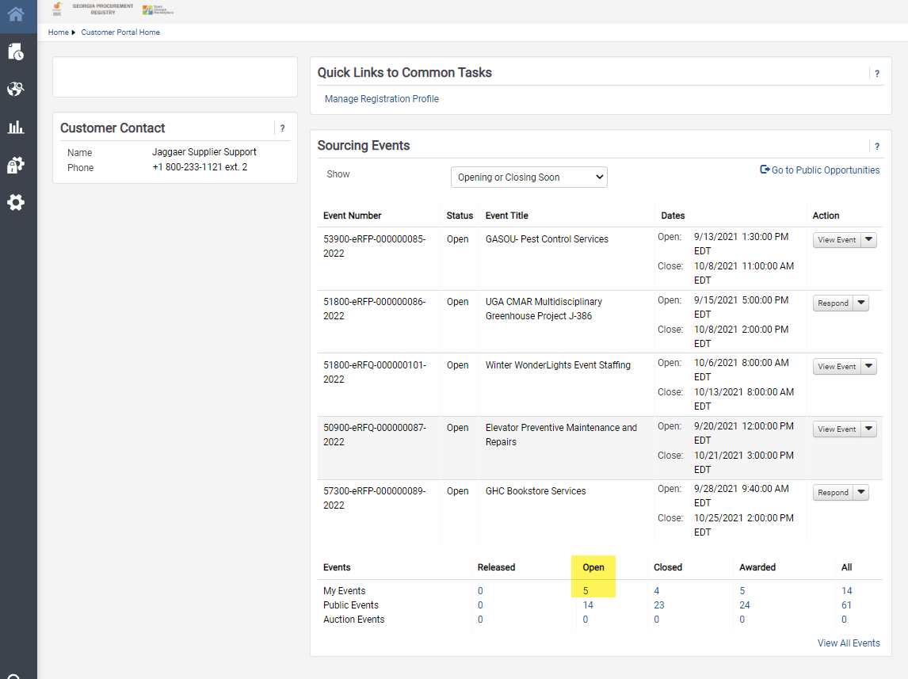
- Complete

