A New Way Forward
DOAS Flexible Benefits Premium Tool
TeamWorks Training Participant Guide
May 2023

Slide 1

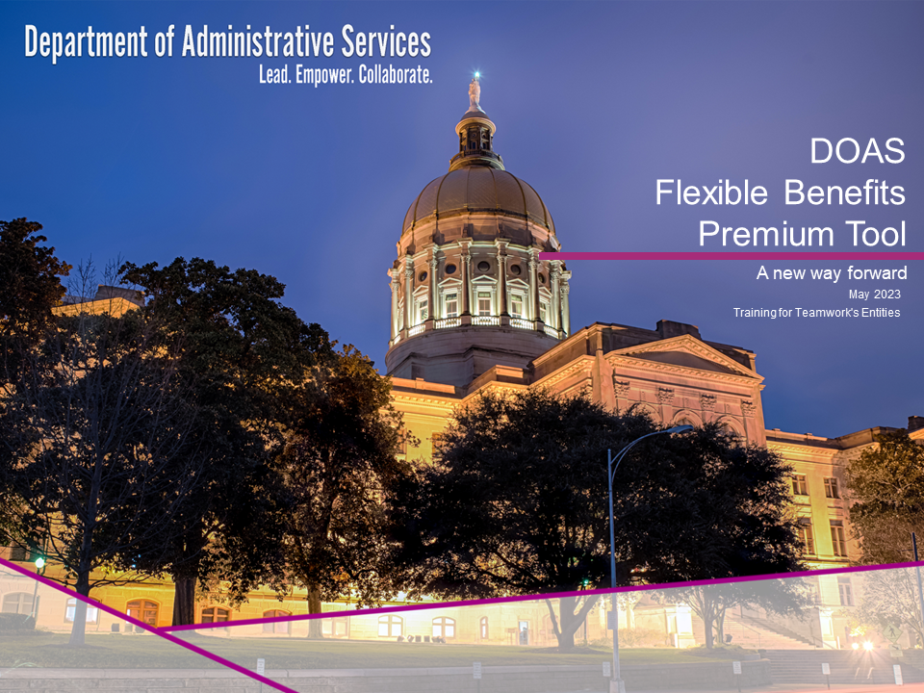

Slide 2

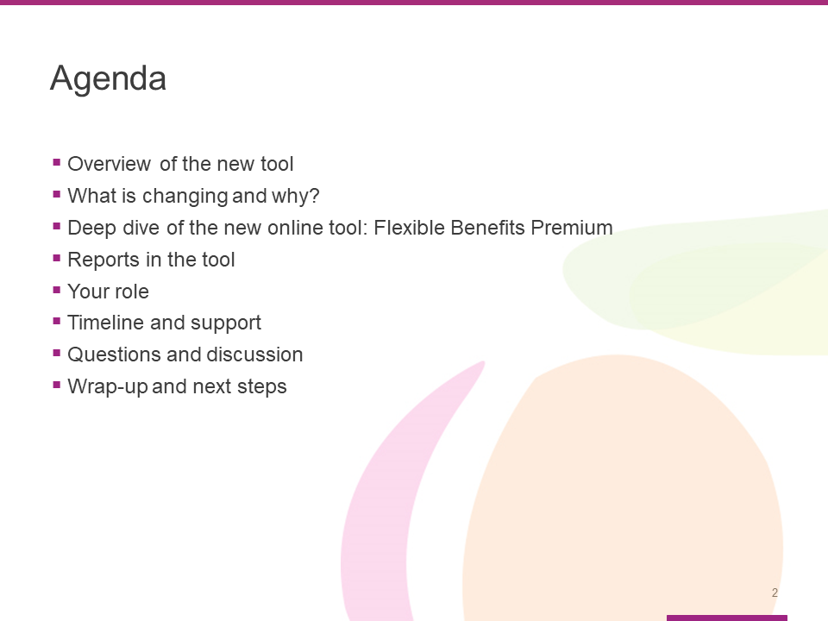

This training will cover the following topics:

- Overview of the new tool
  - What is changing and why?
  - Deep dive of the new online tool: Flexible Benefits Premium
- Reports in the tool
- Your role
- Timeline and support
- Questions and discussion
- Wrap-up and next steps

Slide 3

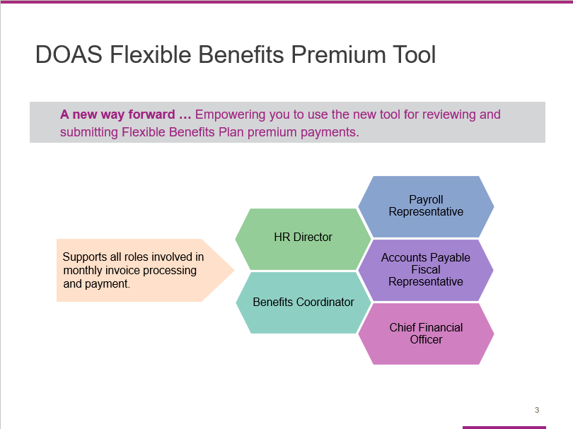

During this session, our goal is to equip and empower you to start using the new payment tool.

Notice the tag line – “A new way forward.” We selected it because this new tool is designed to simplify your workload and make the payment process faster and easier.

This training is designed to support all roles involved in monthly invoice processing and payment, including:
- HR Directors
- Benefits Coordinators
- Payroll Representatives
- Accounts Payable Fiscal Representatives, and
- Chief Financial Officers

Slide 4

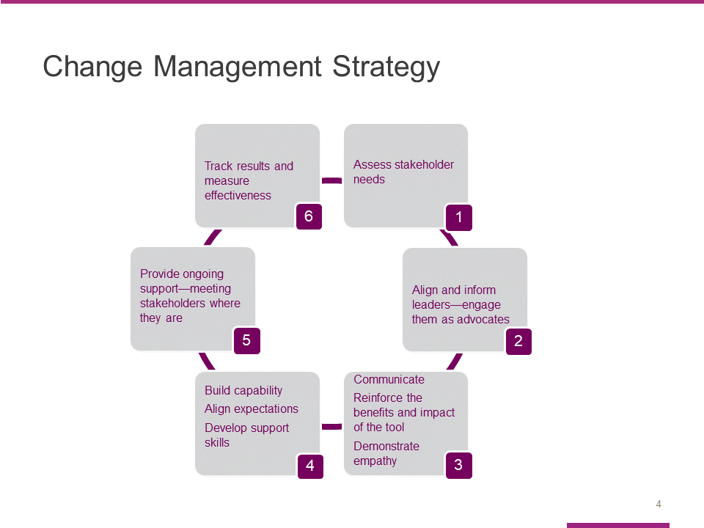

The change management strategy we developed to help you adopt the new Flexible Benefit Premium tool has six phases:

- We started by assessing the needs of our participating entities, who will be the primary stakeholders in this effort.
- We also focused on aligning and informing key leaders so they are comfortable serving as advocates for the new tool.
- The third and fourth phases of our change management strategy are closely related.
- Phase 3 centers around our commitment to communicating clearly – so entities can learn the benefits and expected impact of the new tool. At the same time, we want to demonstrate empathy. Change can be hard, even when it is for the better.
- Phase 4 focuses on building capability by helping impacted entities get comfortable using the new tool, making sure they understand what is expected and helping them develop the necessary skills. Today’s training is a key component of Phase 4.
- Effective change management also requires that we provide impacted entities with ongoing support by meeting them where they are in the learning/adoption process.
- The final component of our change management strategy is to track results and measure the effectiveness of our efforts.
Slide 5

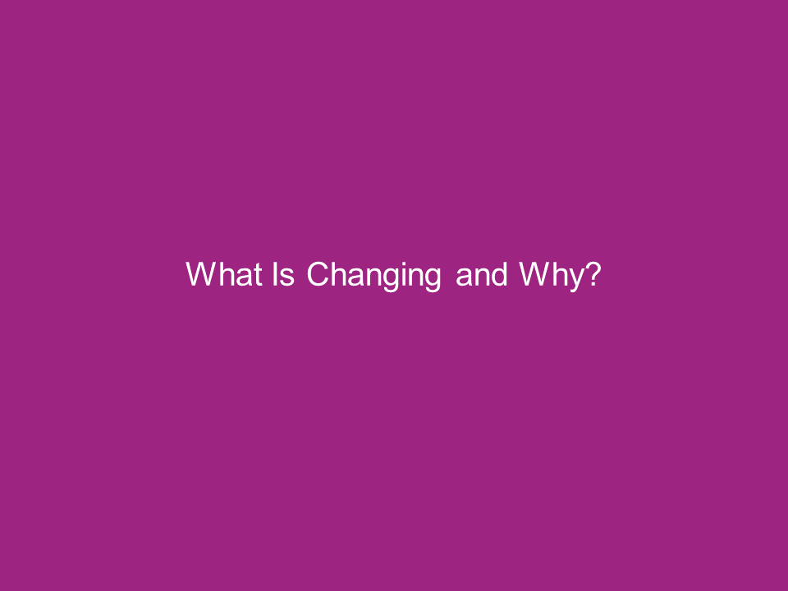

During this section, we will quickly recap what’s changing and why.

Slide 6

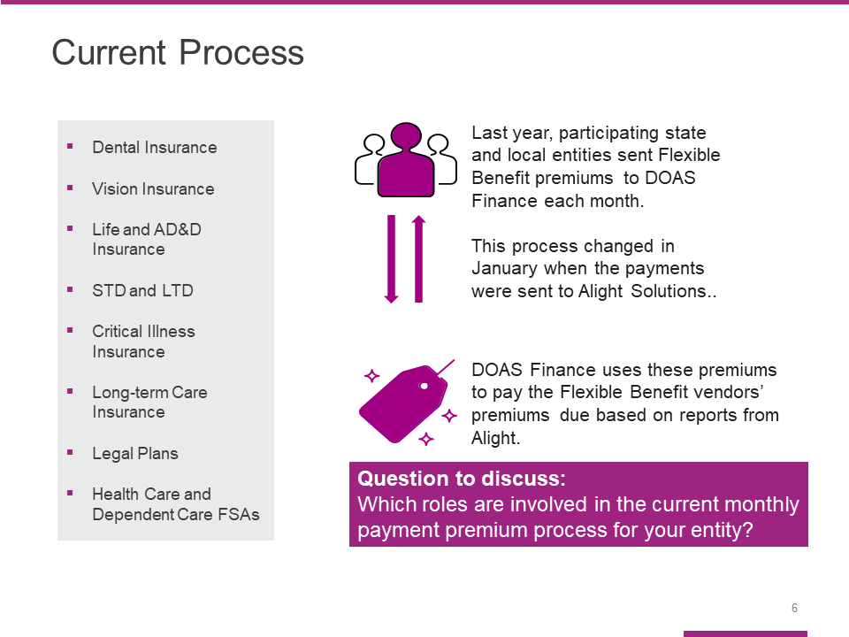

As you know, the Georgia Department of Administrative Services (DOAS), Human Resources Administration (HRA) division is dedicated to providing HR and talent management solutions that empower state entity HR and business leaders to manage their workforce in an effective and efficient manner.

One of the most critical services we provide is the administration of the State of Georgia Flexible Benefits Program, including:
- Dental Insurance,
- Vision Insurance,
- Life and AD&D Insurance,
- STD and LTD (Short-Term Disability and Long-Term Disability),
- Critical Illness Insurance,
- Long Term Care Insurance,
- Legal Plans, and
- Flexible Spending Accounts for Health Care and Dependent Care.

The visual on the right of the slide illustrates how the monthly process has worked, and how it works now. As you can see, participating state entities send Flexible Benefit premiums to DOAS Finance each month. DOAS Finance uses these premiums to pay the Flexible Benefit vendors’ premiums due based on reports from Alight Solutions, the GaBreeze Benefits System administrator. ​

Because this process is complex and time-consuming, DOAS and Alight have partnered to improve the process through a more streamlined and efficient online tool.

Question to consider: Which roles are involved in the current monthly payment premium process for your entity?
Slide 7

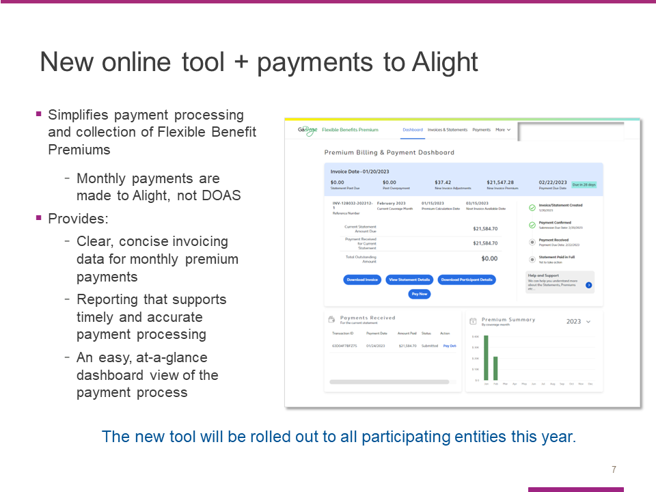

To address these challenges and simplify your work effort, we have partnered with the GaBreeze Benefits System administrator, Alight Solutions, to develop a new online tool that will replace this process.

This tool will provide us with a system that provides clear, concise invoicing data for premium payments, as well as reporting that supports timely and accurate payment processing and reconciliation.
It was developed specifically for DOAS and you, our participating entities.

More importantly, it is designed to simplify payment processing and collection – providing you with easy, online access to clear and concise statements, invoices and reports.

And here’s the best news: The new tool is rolling out to all participating entities now. You will start using the tool for upcoming invoices.

Slide 8

In this section, we will take a closer look at the new tool.

We will start by reviewing the key features using screenshots.

Slide 9

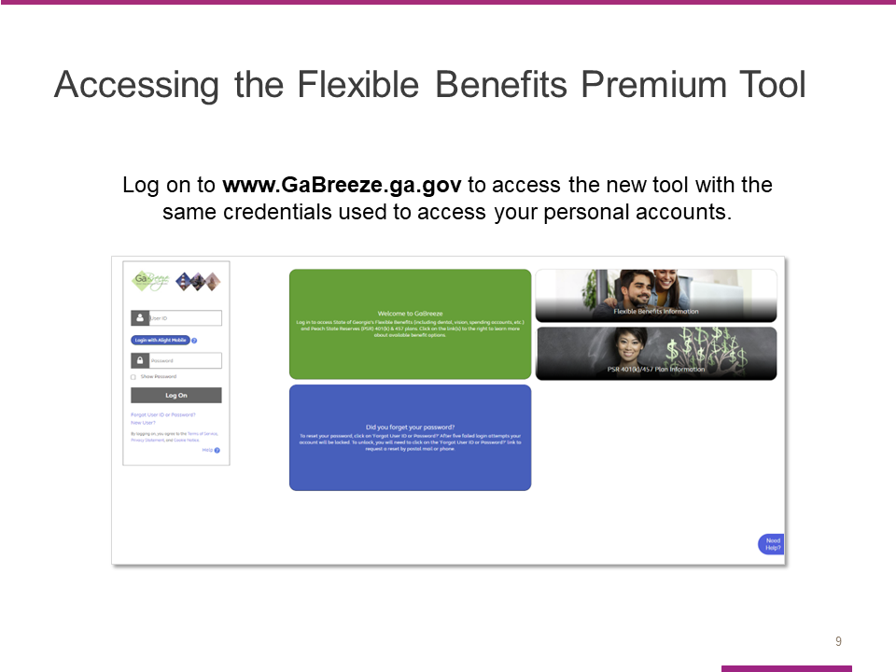

Going forward, you will use the Flexible Benefits Premium tool to view your remaining outstanding premium amount and to make applicable payments.

All users will access the new online tool through the UPoint GaBreeze site at www.GaBreeze.ga.gov (under the Administrative Tools section).

You will need your User ID and password to authenticate into the site.

If you do not remember your credentials, select the Forgot User ID or Password link under the Log On button. Then follow the prompts to reset your credentials. If you need to reset your credentials, if you have a cell phone number online, you can receive a one-time code to update your password. Otherwise, your password will be sent to you via the US Postal Service.

If you are new to the site, select the New User link, also under the Log On button, and then follow the prompts to set up your credentials.

Finally, please note that the User ID and password are the identification credentials used to access their personal accounts and not the User ID used to access the normal GaBreeze Employer Portal.

Slide 10

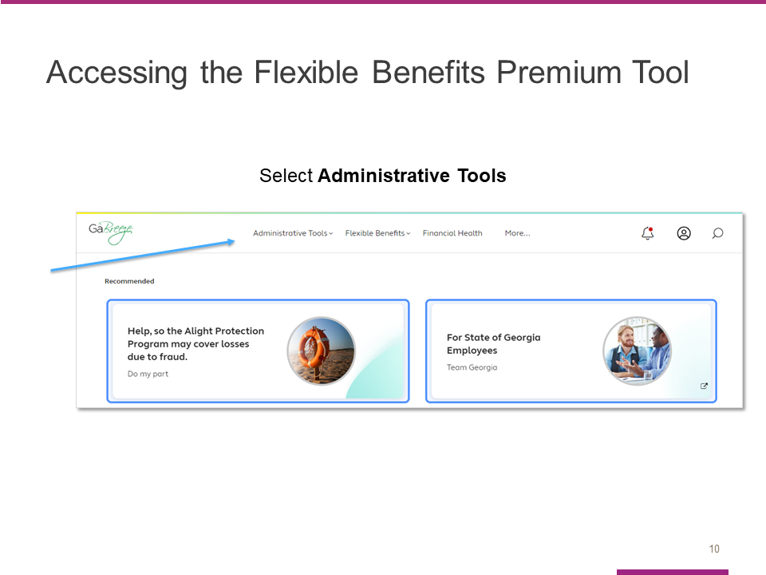

Once you are logged into the GaBreeze site you can access the Flexible Benefits Premium tool via the top drop-down menu.

Entity users who have been granted access to the tool will see an Administrative Tools drop-down on the far left at top of the page.

Selecting this drop-down will route the entity user to a page which will link directly to the Flexible Benefits Premium tool.

Slide 11

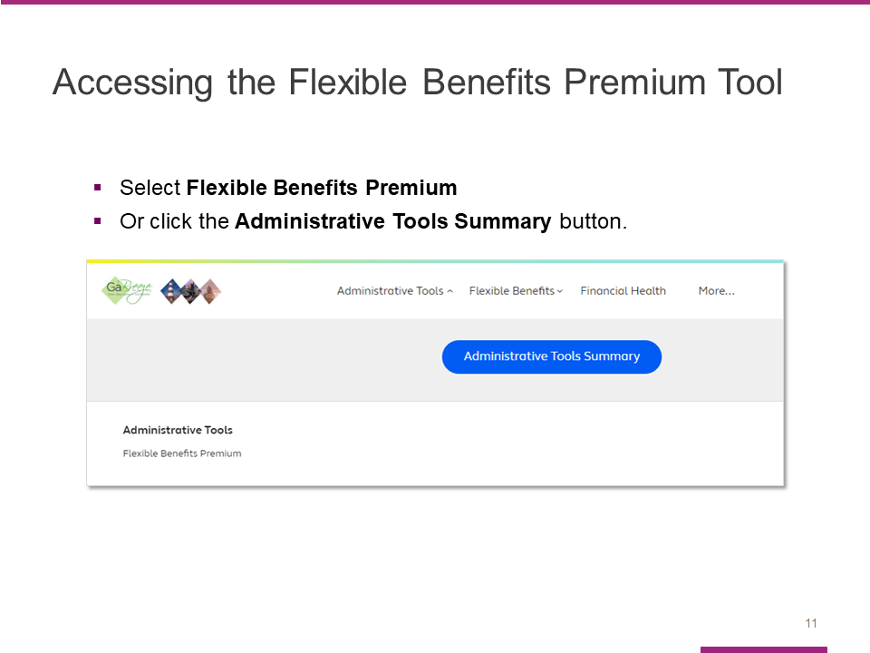

After you select the Administrative Tools drop-down, you will see this page. The words Flexible Benefits Premium are a direct link out to the tool.

In addition, a new Administrative Tools Summary button appears. This is where Alight will be storing access to multiple tools, including the Flexible Benefits Premium.

Clicking on this button will take you to the Tools Summary page.

Slide 12

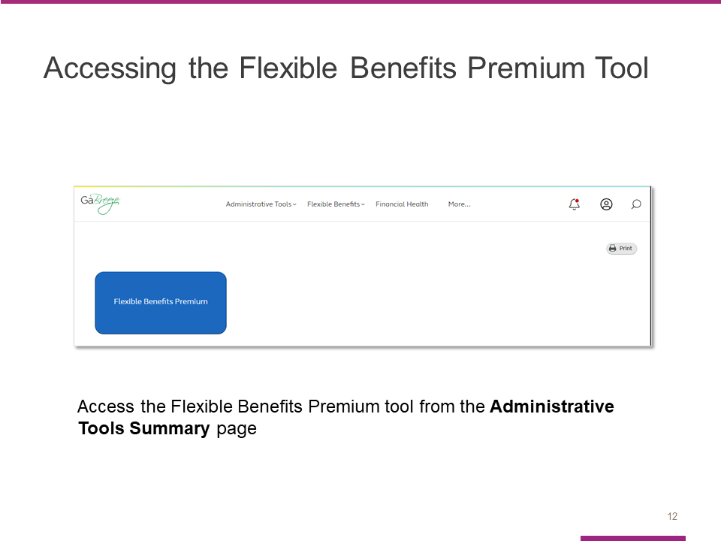

The Flexible Benefits Premium tile can also be clicked on this page and will route the entity user directly into the Flexible Benefits Premium tool.

Slide 13

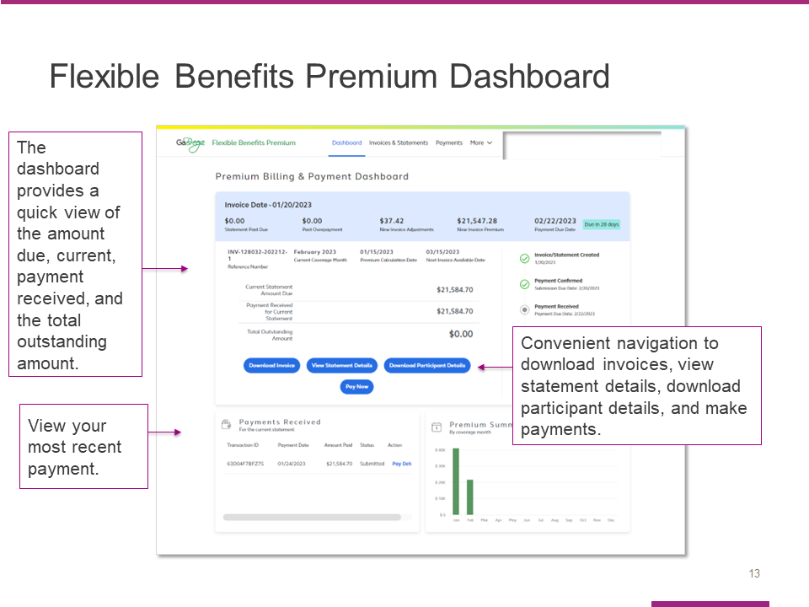

This dashboard is the first screen you will see after you access the new tool.

It provides an easy, at-a-glance view of the payment process.

The light blue bar at the top shows the invoice date as well what makes up the current amount due, specifically:
- The new invoice premium,
- The new invoice adjustments, and
- Any past due amounts.

This section of the dashboard also shows the invoice/statement date and the payment due date.

The section under the blue bar shows the current statement amount due, the payment received for the current statement, and the total outstanding amount.

You can use the dark blue buttons to download the invoice, view statement details, download participant details, or pay.

The Payments Received section allows you to view your most recent payment.

Slide 14

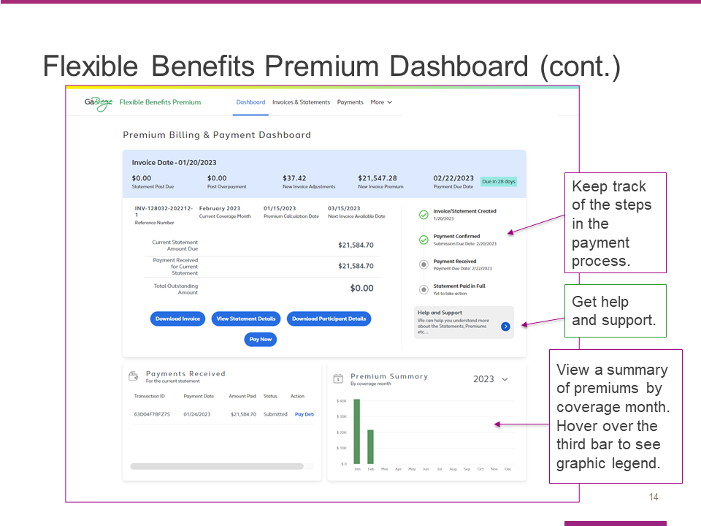

On the right side of the dashboard, you will see a tracker that helps you keep track of where you are at in the payment process.

You will also find a help and support button that connects you to additional resources.

The bottom section of the dashboard allows you to view payments received as well as a premium summary. Hover over the third bar to see the graphic legend.

Slide 15

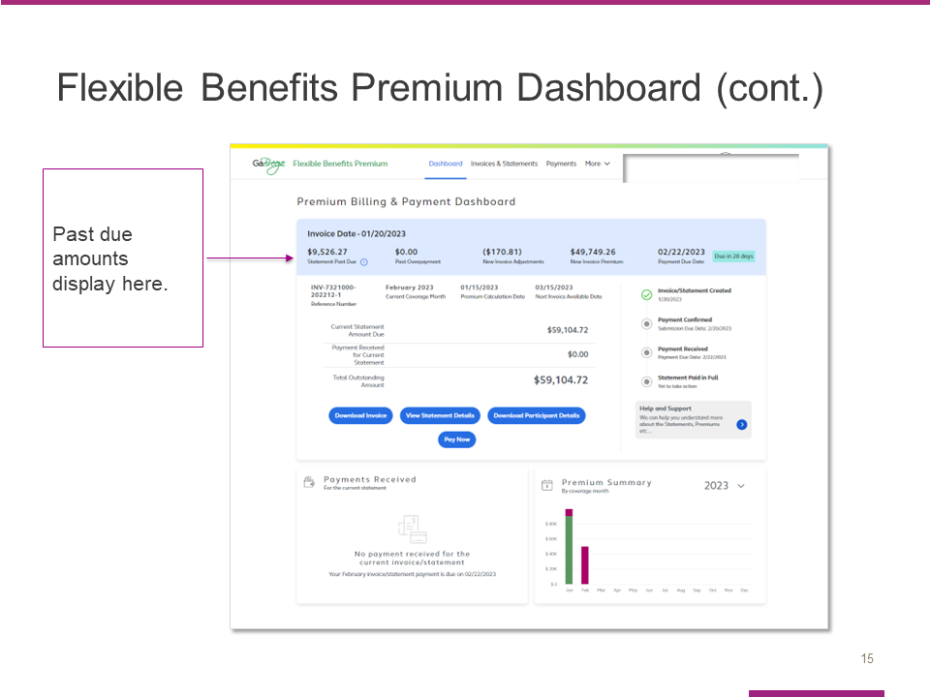

The tool allows you to easily view past due amounts from the Invoice Date section at the top of the page.

Slide 16

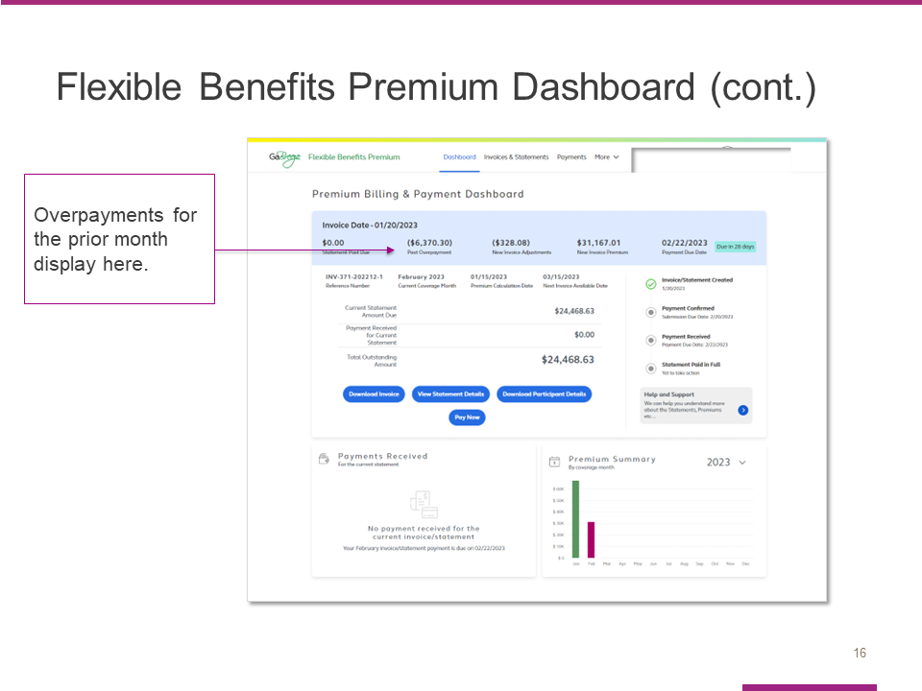

The Invoice Date section also shows any overpayments for the prior month.

Slide 17

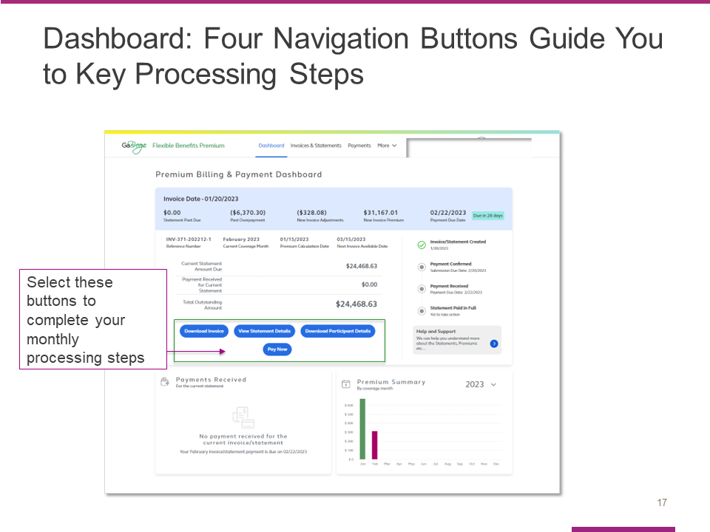

The four blue navigation buttons are another important feature of the dashboard.

These buttons are designed to guide you through the four key invoice processing steps each month:

- Downloading the invoice

- Viewing statement details

- Downloading a file with participant details, and

- Paying the invoice.

Slide 18

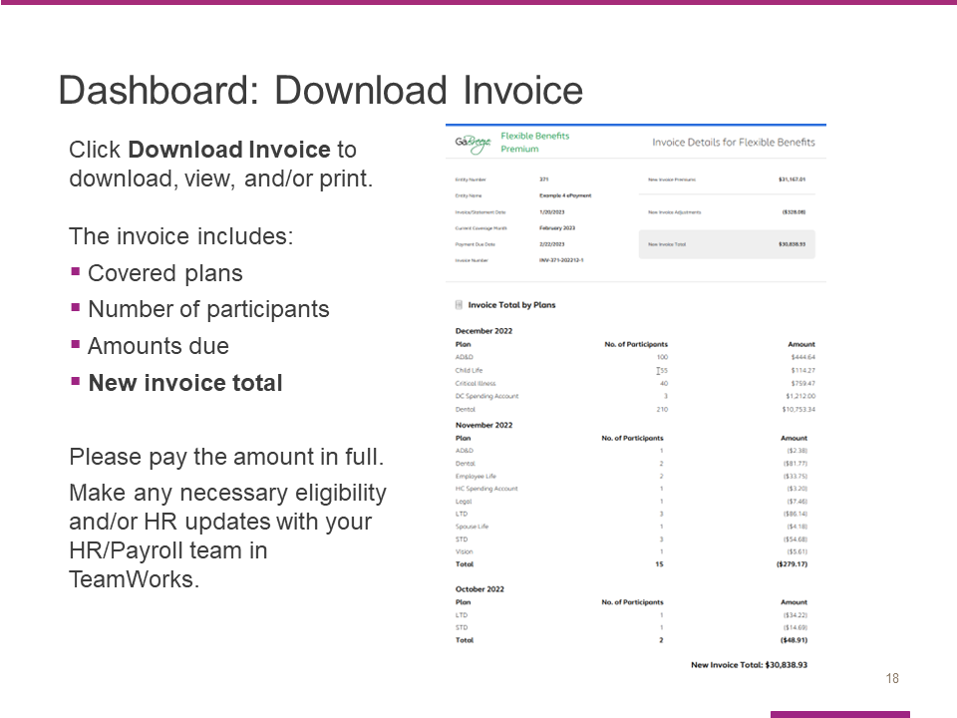

When you select the Download Invoice button from the dashboard, the tool will open your most recent invoice.

It is important to check the invoice to confirm the following information for each month:

- Covered plans,

- Number of participants, and

- Amounts due.

The new invoice total is shown at the bottom of the invoice.

Please pay the amount in full.

If any eligibility and/or HR updates are needed, please make them with your HR/Payroll team. Note that manual entities will use the Employer Website tool.

Slide 19

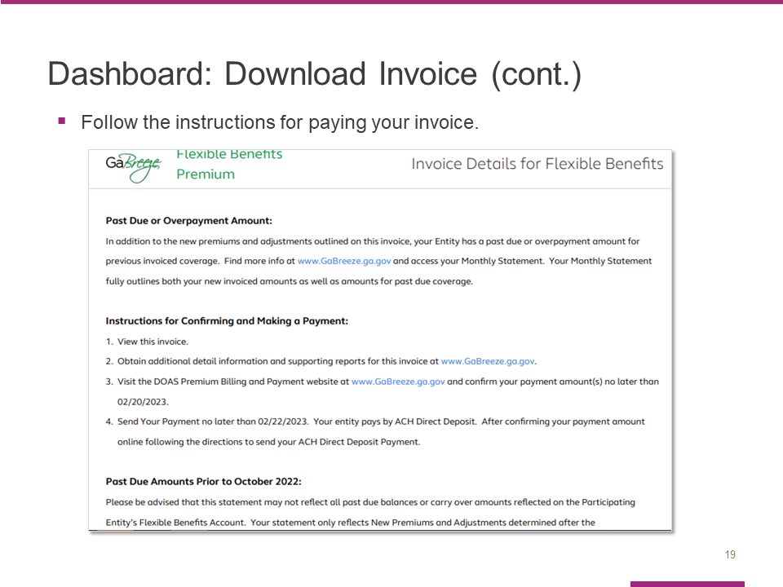

Be sure to follow the instructions provided when you pay your invoice.

Slide 20

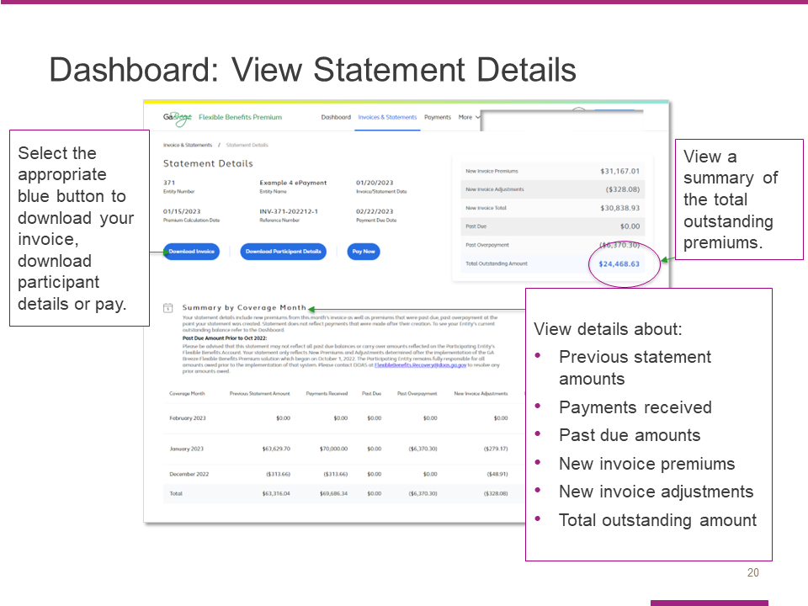

When you select the View Statement Details button, you will link to the Statement Details page that is shown here.

You can use the three blue navigation buttons to download your invoice, download a file with participant details or pay.

This page also provides a summary of the total outstanding premiums, as well as a Summary by Coverage Month section with details about:
- Previous statement amounts,
- Payments received,
- Past due amounts,
- New invoice premiums and new invoice adjustments, and
- The total outstanding amount.

Slide 21

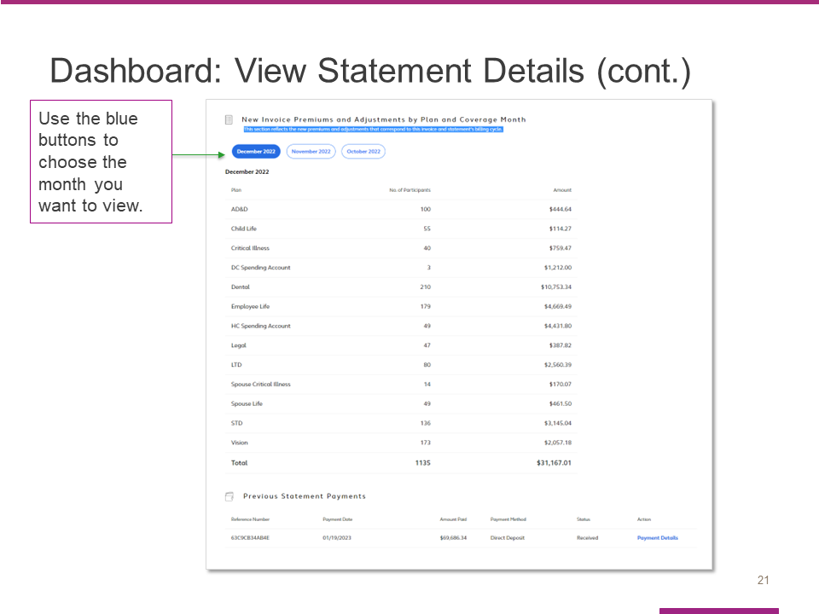

Here is a screenshot of the additional information you’ll see as you scroll through the statement screen.

Use the blue buttons to choose the month you want to view.

Slide 22

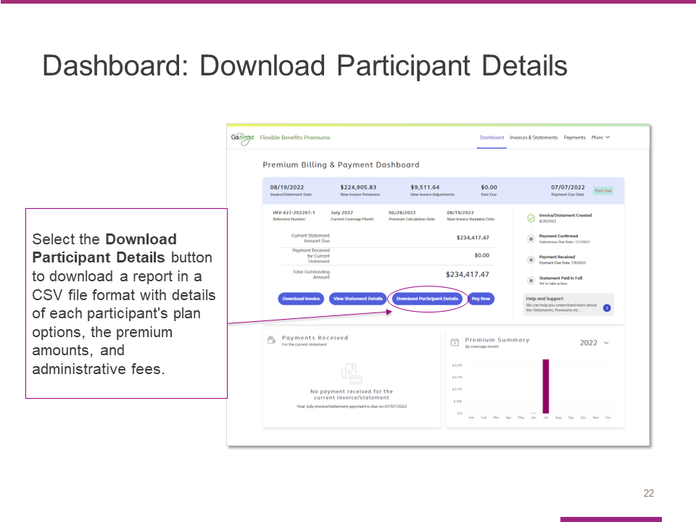

After you select the Download participant details button, the tool will download a report in a CSV file with details of each participant’s plan options, the premium amounts and administrative fees.

Review this file to confirm the number of participants covered since that is what determines the premium amounts due.

Slide 23

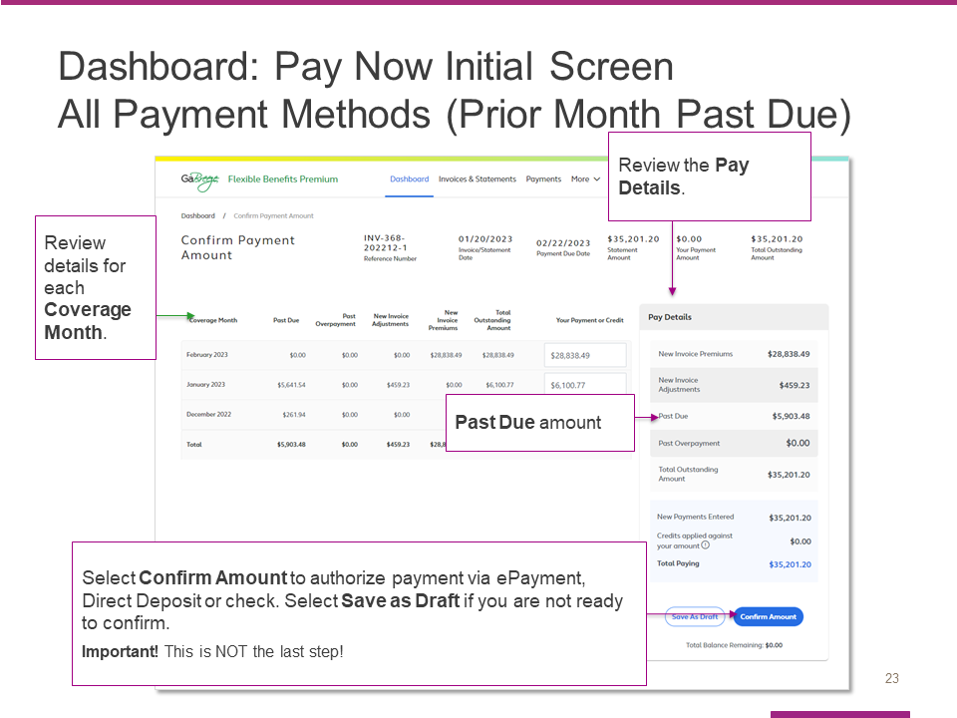
Here is the screen that appears when you select the Pay now button from the dashboard. This initial screen is the same whether your entity pays by ePayment, Direct Deposit or Check – with one exception that I’ll cover at the end.

Start by reviewing the details for each Coverage Month.
- Coverage Months correspond to the actual coverage of your employees. However, Coverage Months premiums are not always calculated in the actual month of coverage. This is because retroactive enrollments (such as a birth of a child enrolled in coverage after birth) can adjust previous months’ coverage.
- Therefore, in each invoice you will likely see nearly all of your premiums in the current Coverage Month, but you may also see adjustments to previous Coverage Months.
- Adjustments can be both positive (additional money due) or negative (credits against other premiums due).

The next step is to review the pay details for the current amount due.

When you have completed that step, hit Confirm Amount to authorize your payment via ePayment, ACH or check (depending on your agency). Note that this is not the last step in the confirmation process. It simply takes you to the NEXT steps in the payment/confirmation process.

If you are not ready to confirm and pay, you can select Save as draft before you leave the page.

Please note: If the amount Confirmed is not the exact same amount Alight Received, the issue will appear on Alight’s Unallocated Report. Alight reviews this report daily and will delete the Confirmed amount in the tool if the amounts do not match. The entity will need to enter a new Confirmed Amount. These are manual processes, and entities need to ensure that after they receive their monthly invoices, that the appropriate amounts are Confirmed and Paid timely, and for the Reconciliation process that the Alight and Payroll reports are reviewed, so the appropriate updates can be made to the TeamWorks HR/Payroll system, which interfaces with Alight.

Refer to the FAQs for help on how to enter payment data.

This screen is the same for all 3 payment methods I just mentioned. However, the next steps and screens differ by payment method. As a result, there is a different message at the bottom of this screen with specific information about next steps for each payment method.

Final note before we move on: This example shows a Past Due amount from the prior month of $4,903.48. This Past Due amount is ADDED to the Total Outstanding Amount on this screen.
Slide 24

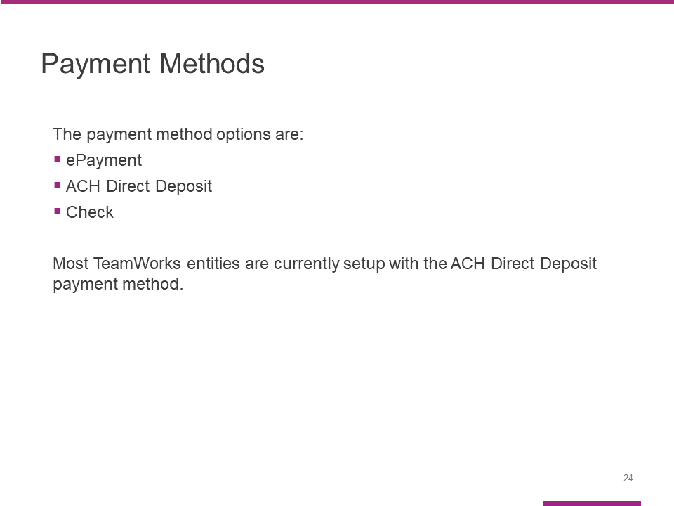

Participating entities need to choose one of these forms of payment within 1 week of this training session:
- ePayment
- ACH Direct Deposit – Most TeamWorks entities are setup for ACH Direct Deposit
- Check

We’ll cover the payment steps for each form of payment next.

Slide 25

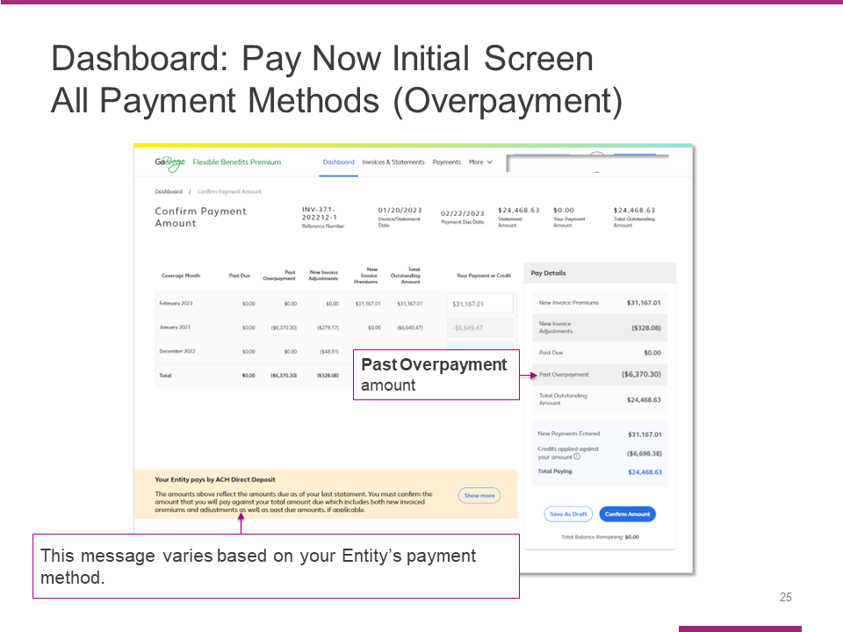

This screenshot is identical to the one we just viewed with one exception:

Instead of showing a Past Due amount for the prior month, it shows a Past Overpayment amount.

As you can see, the Past Overpayment is SUBTRACTED from the Total Outstanding Amount.

Note: The message in the tan box at the bottom of the screen varies by payment method. This example shows the message for Entities that pay by ACH Direct Deposit. If your Entity uses a different payment method, you will see a different message.

Slide 26

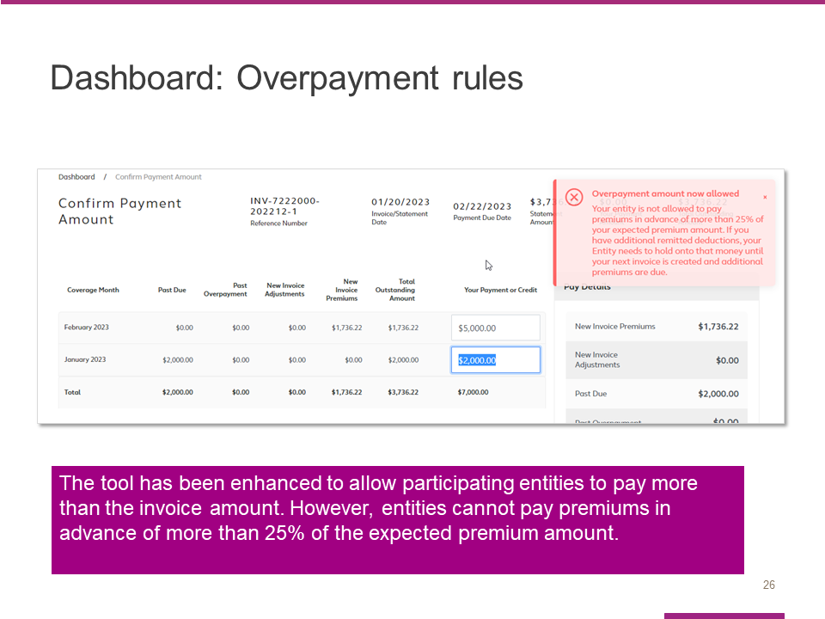

All entities can make overpayments if they so desire.

However, there is a limitation on how much they can overpay.

That limit is no more than 25% of the total outstanding balance for the current cycle.

An entity that attempts to pay more than the limit will see the Overpayment Edit shown on this screenshot.

Slide 27

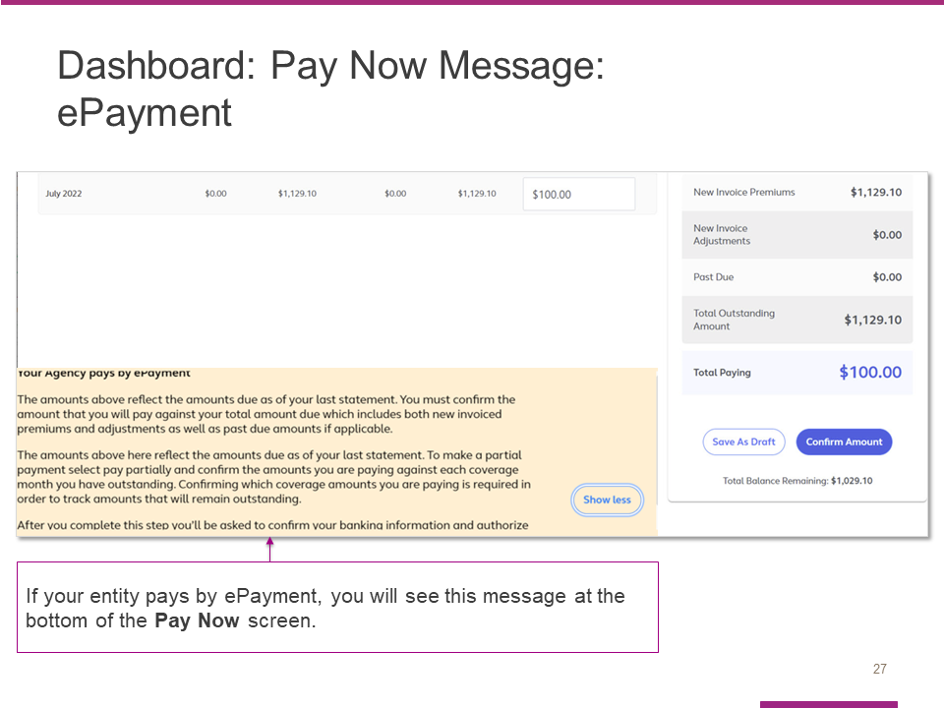

If you are paying by ePayment, you will see this message at the bottom of the Pay Now Screen. Please review before you select Confirm Amount.

Slide 28

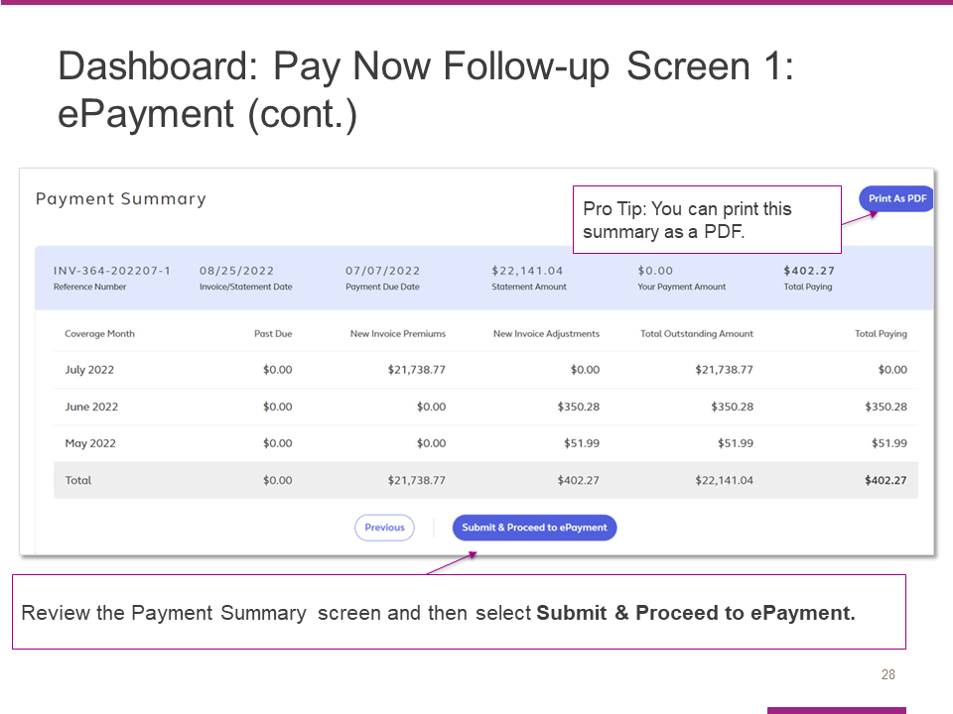

You will see this Payment Summary Screen after you select Pay Now.

Review the summary for each month and select Submit & Proceed to ePayment.

For entities that are paying via ePayment, the authorization to formally submit the payment will be limited to the AP Fiscal Representative and Chief Financial Officer at the entity.

Slide 29

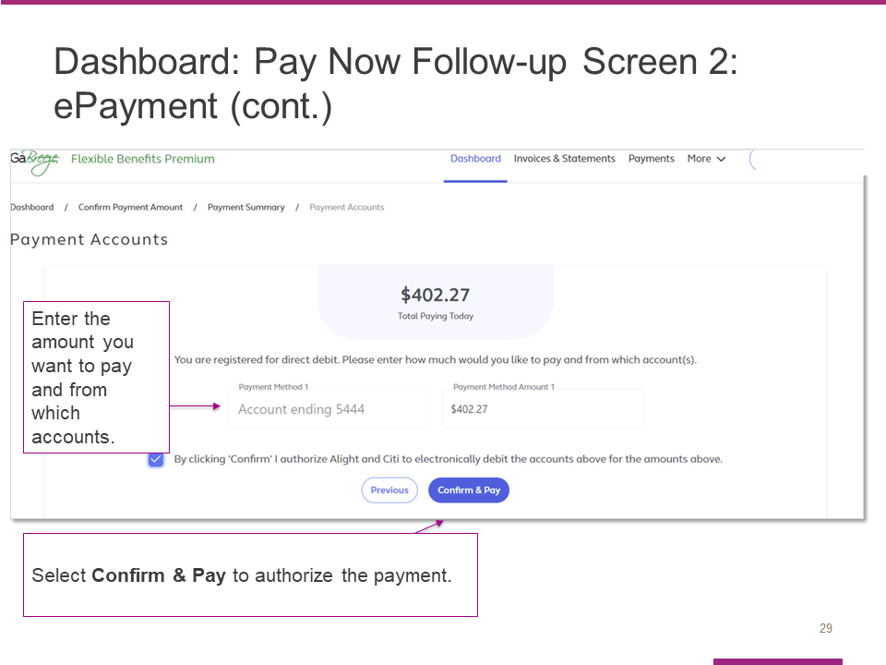

Here is the screen that appears after Submit & Proceed to ePayment is selected.

The AP Fiscal Representative or Chief Financial Officer will need to enter the amount they want to pay and indicate the bank account the payment should be taken from.

Their final step is to select Confirm & Pay to authorize payment.

Slide 30

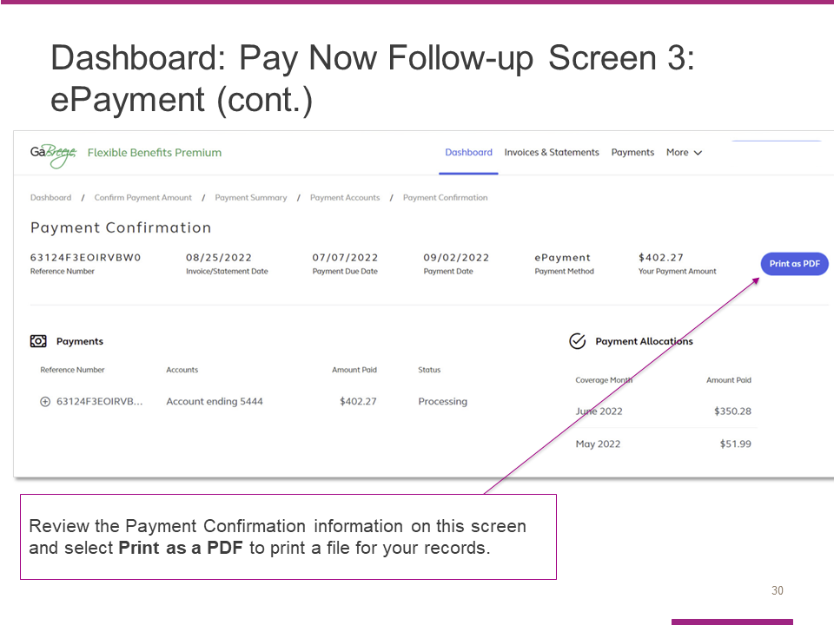

This Payment Confirmation screen will appear after the ePayment is authorized.

The entity’s AP Fiscal Representative or Chief Financial Officer should review and then select Print as a PDF to obtain a copy for your entity’s records.

Slide 31

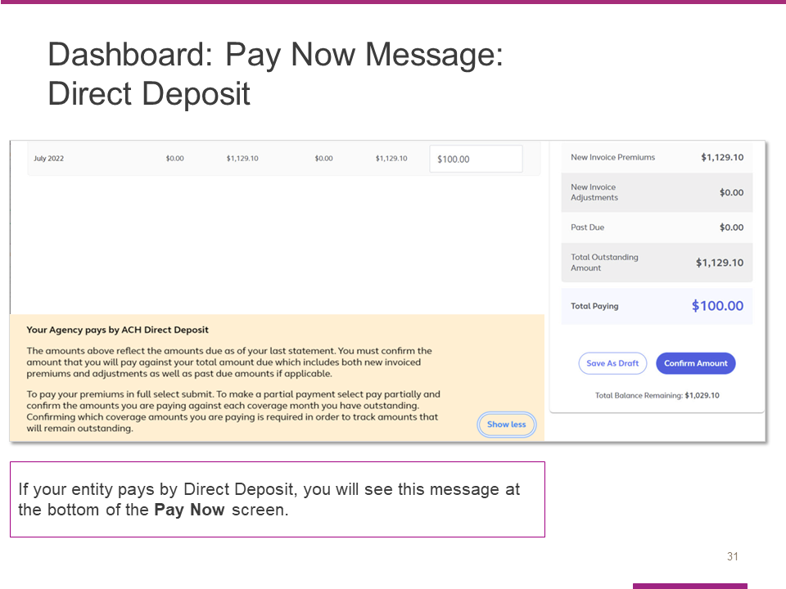

If you are paying by Direct Deposit, you will see this message at the bottom of the Pay Now Screen. Please review before you select Confirm Amount.

Slide 32

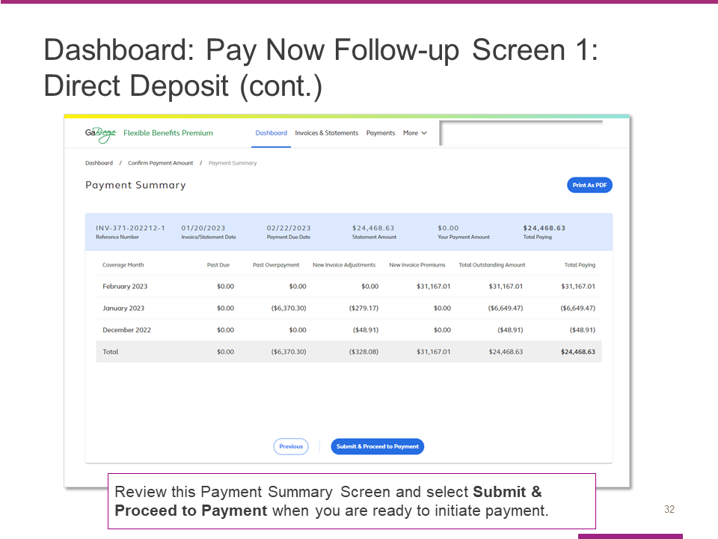

Here is the Payment Summary Screen that appears for entities that pay by Direct Deposit.

Review the summary and then select Submit & Proceed to Payment to begin the payment process.

Slide 33

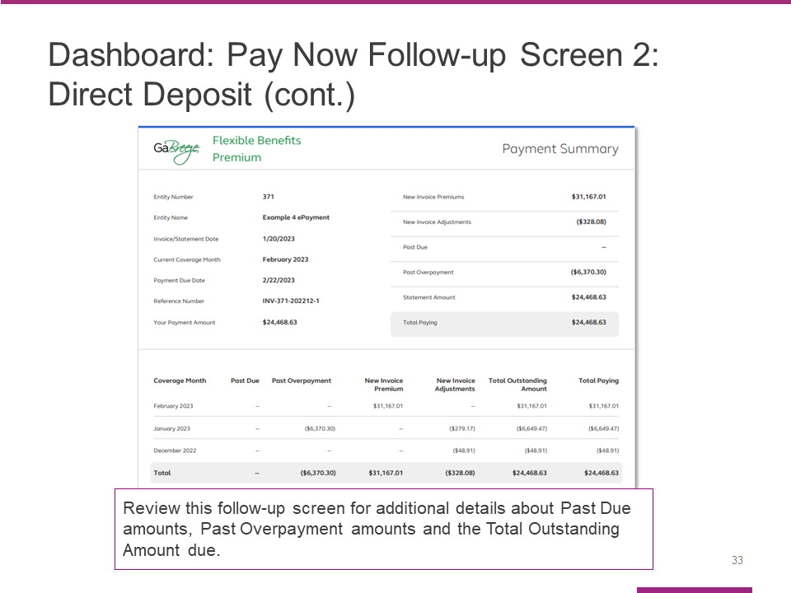

After you begin the payment process, you will see this screen, which contains details about any Past Due amounts, Past Overpayment amounts and your Total Outstanding Amount due.

Slide 34

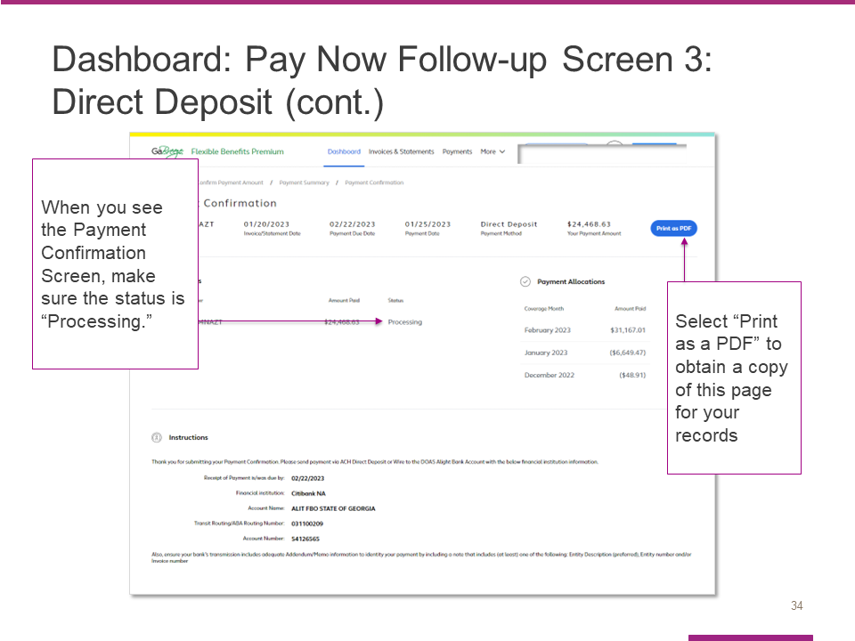

After you begin the payment process, you will see this Payment Confirmation Screen.

Check to make sure the status is Processing.

Select Print as PDF to obtain a copy of this page for your records.

Slide 35

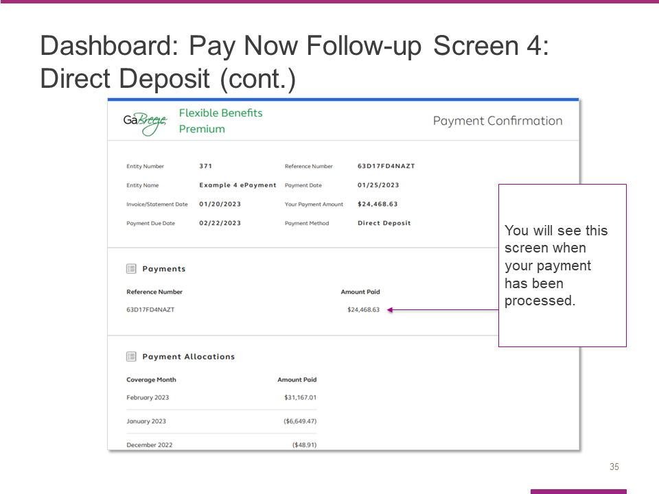

This screen shows what you will see when your payment has processed.

Slide 36

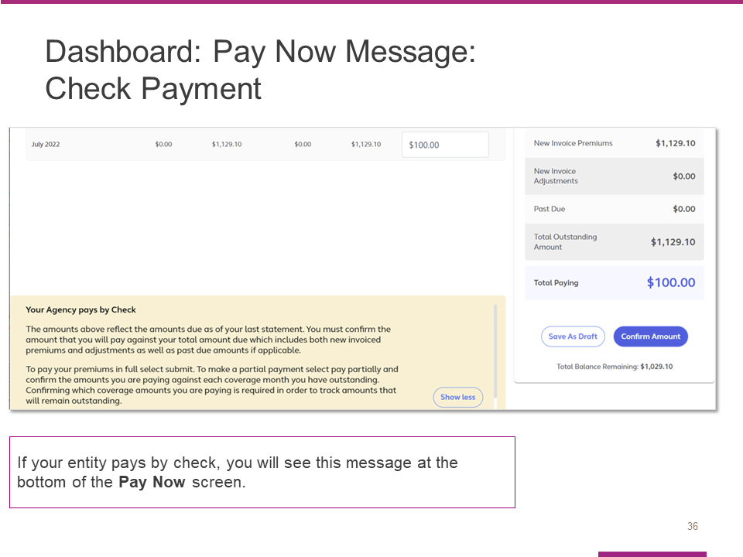

If your entity pays by check, you will see this message at the bottom of your Pay Now screen.

Review this message before you select Confirm Amount.

Slide 37

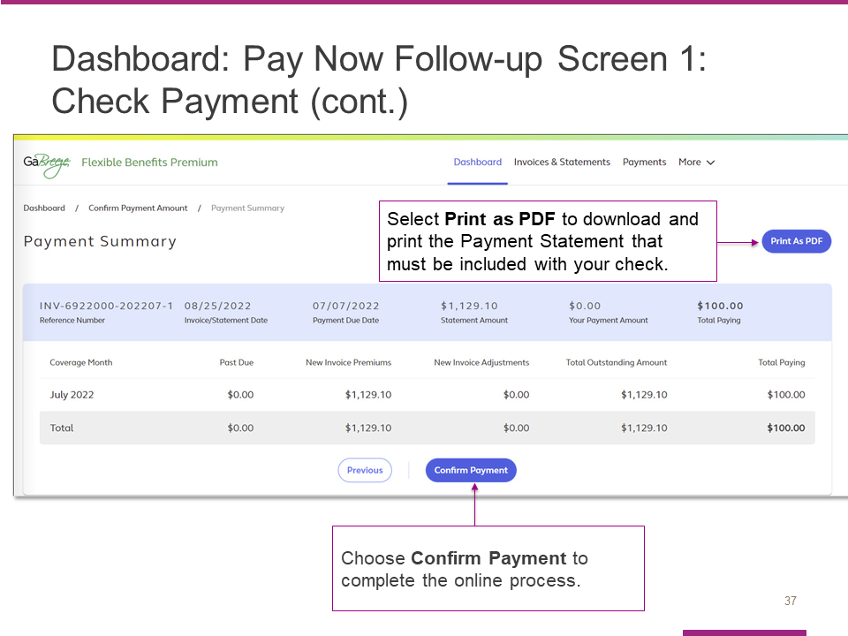

After you confirm your payment amount on the prior screen, you will see this Payment Summary screen. You need to complete two steps to process your payment:

First, select the Print as PDF button to download and print the payment statement that must be included with your check payment.
- The statement has instructions on where and by when to mail the check. It also includes prepopulated information that facilitates the processing of the check at the Alight/Citi lockbox.
- A manufactured number included on the statement is keyed along with the check.
- Alight Solutions then uses this number to associate the check payment with the correct entity.
Second, after you have downloaded and printed the statement, select Confirm Payment to complete the online process.

Slide 38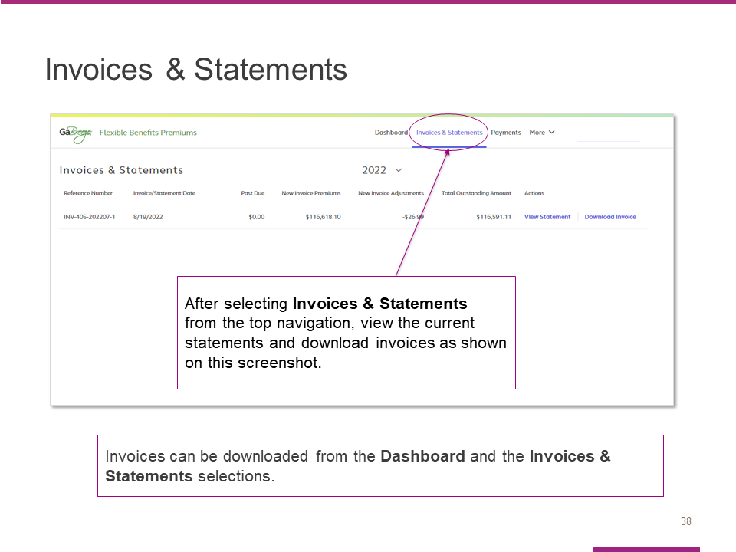

Now we’ll discuss invoices and statements.

The Invoices & Statements link at the top of the dashboard takes you to a page where you can view current statements and download invoices.

Your entity receives both an invoice and statement.

Slide 39

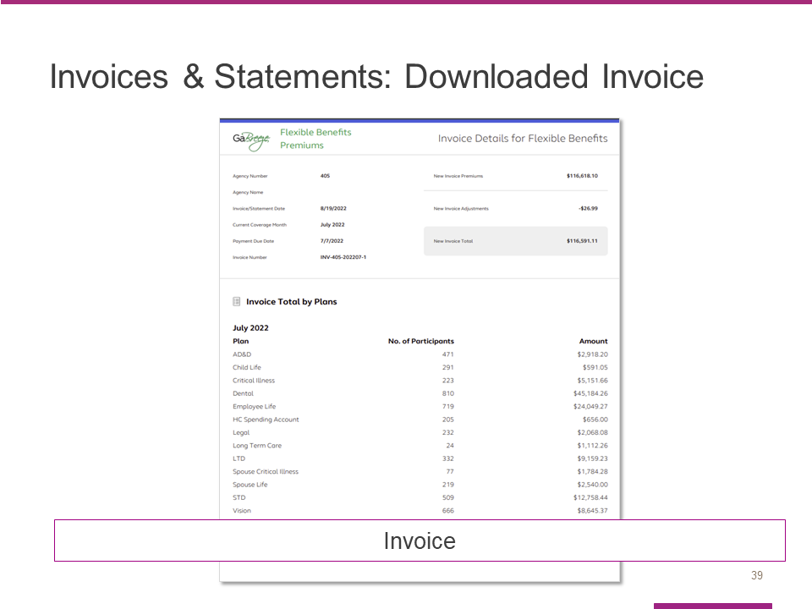

The invoice can be downloaded from the site as a PDF and shared within your entity for financial approval and routing.

Your invoice includes new premiums and new adjustments that have been calculated in the current billing cycle.

Slide 40

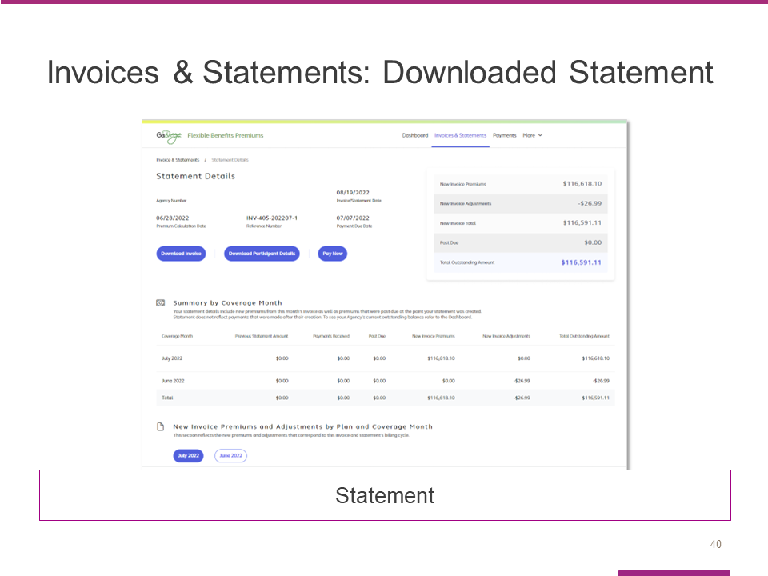

Your monthly statement can be viewed online and shows the same details of new premiums and new adjustments included in your invoice.

In addition, your statement shows payments received since your last invoice/statement.

It also shows any remaining past due balances if any previous invoices were not paid in full when the statement was created.

Slide 41

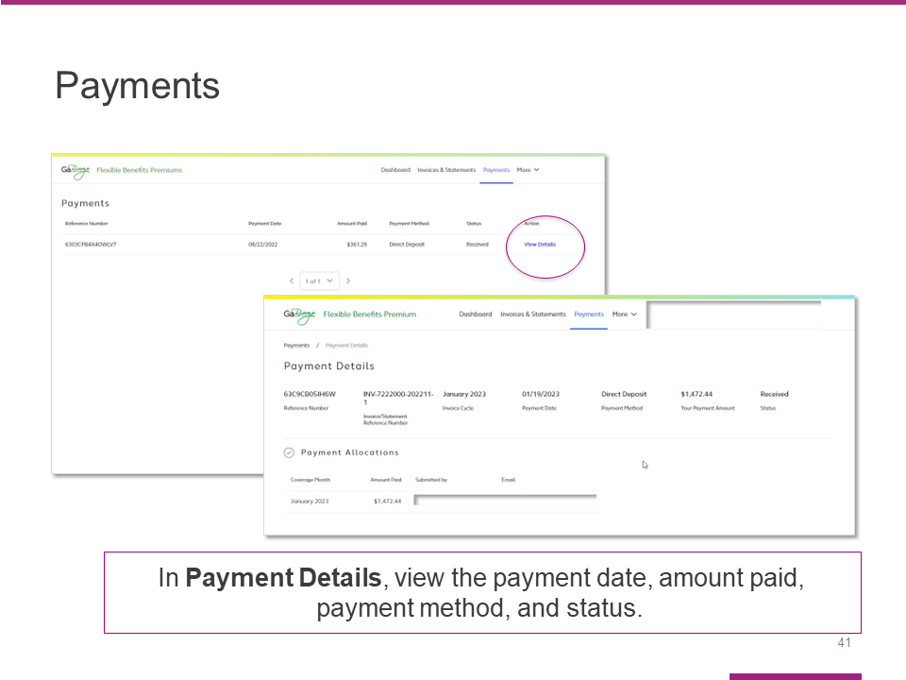

The next link in the top navigation takes you to the Payments page, where you can view the payment date, amount paid, payment method and status.

From the Payments page, you can select the View Details link to reach the Payment Details page.

Once you reach the Payment Details page, you can view the payment date, amount paid, payment method and status.

Slide 42

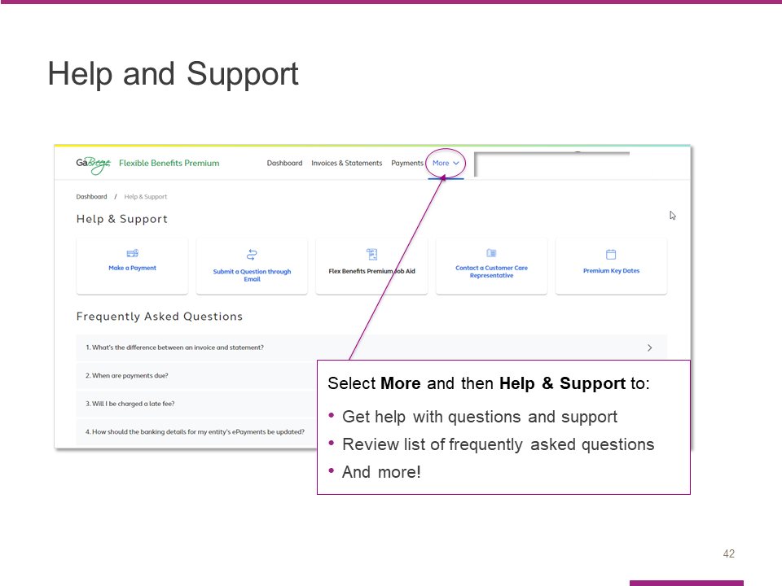

Select More and then Help & Support to:
- Get help with questions and support
- Review list of frequently asked questions, or FAQs
- And more!

Slide 43

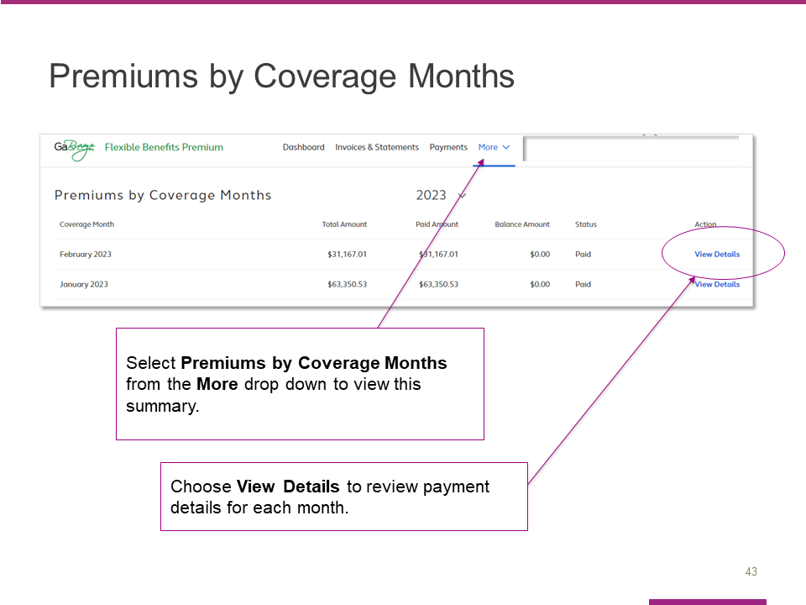

The More menu contains a link to the Premiums by Coverage Months summary page.

After you review the information on this screen, select View Details to proceed.

Slide 44

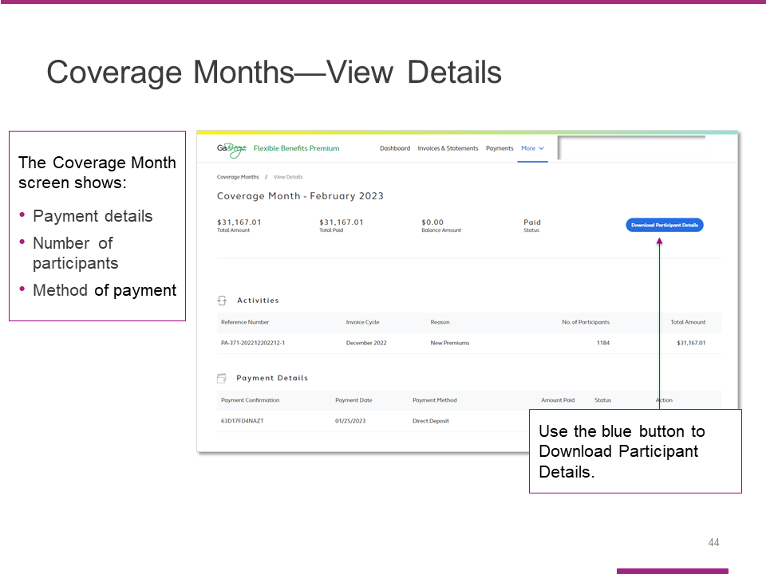

In addition to providing payment details, the View Details page also shows the number of participants and method of payment.

You can also download participant details from this page.

Slide 45

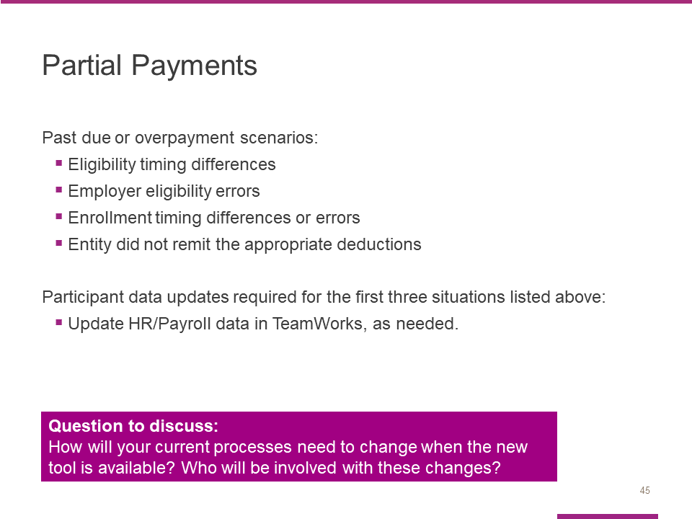

TeamWorks entities are expected to pay the amounts deducted from payroll or invoiced. Those who do not pay the invoice amount will be considered past due.

The financial payment tool will allow entities to pay amounts less or more than what's invoiced; however, if you pay less than the amount invoiced, the below scenarios will still be treated as delinquent/past due:
- Eligibility timing differences – eligibility changed after an invoices' premiums were calculated vs. when payments are submitted.
- Employer eligibility errors – eligibility updates that were not sent to Alight as expected.
- Enrollment timing differences or errors – enrollment processed after an 'invoices' premiums were calculated vs. when payments are submitted or participants who missed enrollments or enrolled in an unintended option.
- The entity did not remit the appropriate deductions from payroll to cover employees' premiums.

For the first three situations, entities are expected to submit participant data updates.
Automated entities, like TeamWorks should work with their HR/Payroll teams to make any necessary updates.

Facilitator:
Allow time for entities to discuss how their current processes will need to change and who will be involved with the changes and what those changes will be. For example: Who will compare the payroll deduction reports to the benefit premium reports? Who will confirm the payments in the tool? Who will ensure the payment is confirmed in the tool prior to the payment being paid to Alight? When will the payroll and benefit reports be compared?

Slide 46

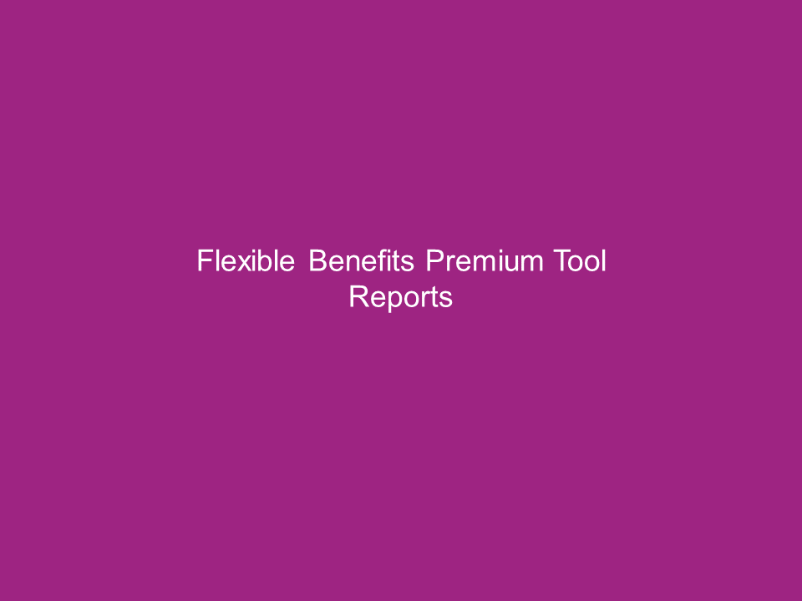

Slide 47

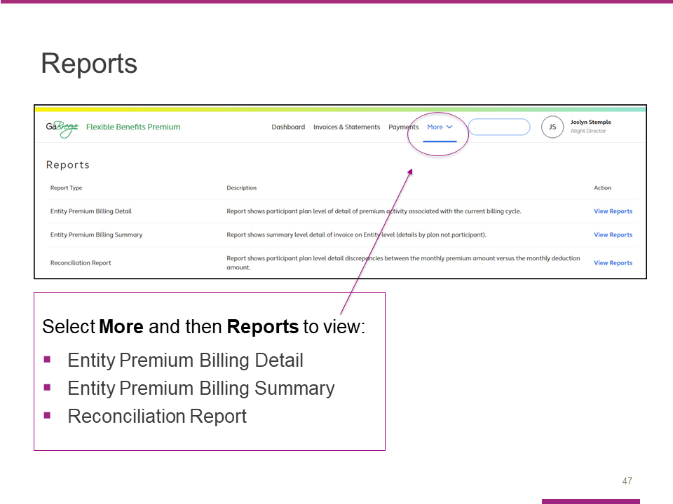

Select More and then Reports to view a screen that lists all available reports, including:
- Entity Premium Billing Detail
- Entity Premium Billing Summary
- Reconciliation Report

You will see a short description of each report as well as a link to the actual report.

Note:
• Entity Premium Billing Detail = FLX Financial Manager Detail Report
• Entity Premium Billing Summary = FLX Financial Manager Summary Report

Slide 48

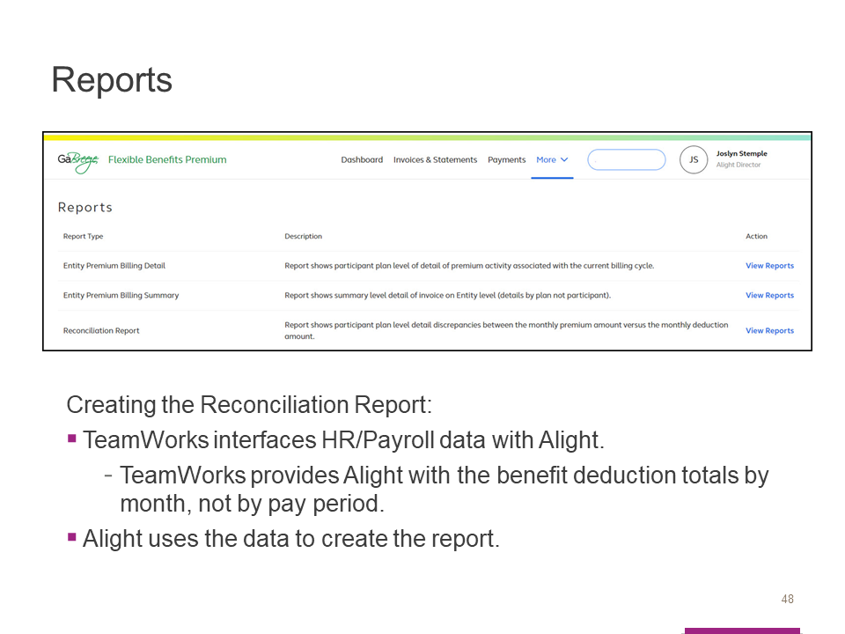

To create the Reconciliation Report:
- TeamWorks interfaces HR/Payroll data with Alight.

TeamWorks provides Alight with the benefit deduction totals by month, not by pay period.
- Alight uses the data to create the report.

Note: TeamWorks automatically sends the pay period deductions to the Accounts Payable voucher.

For some employees in the Reconciliation Report, there may be differences between the payroll monthly total used for the report, compared to the pay period benefits deduction totals from the pay period vouchers.

Slide 49

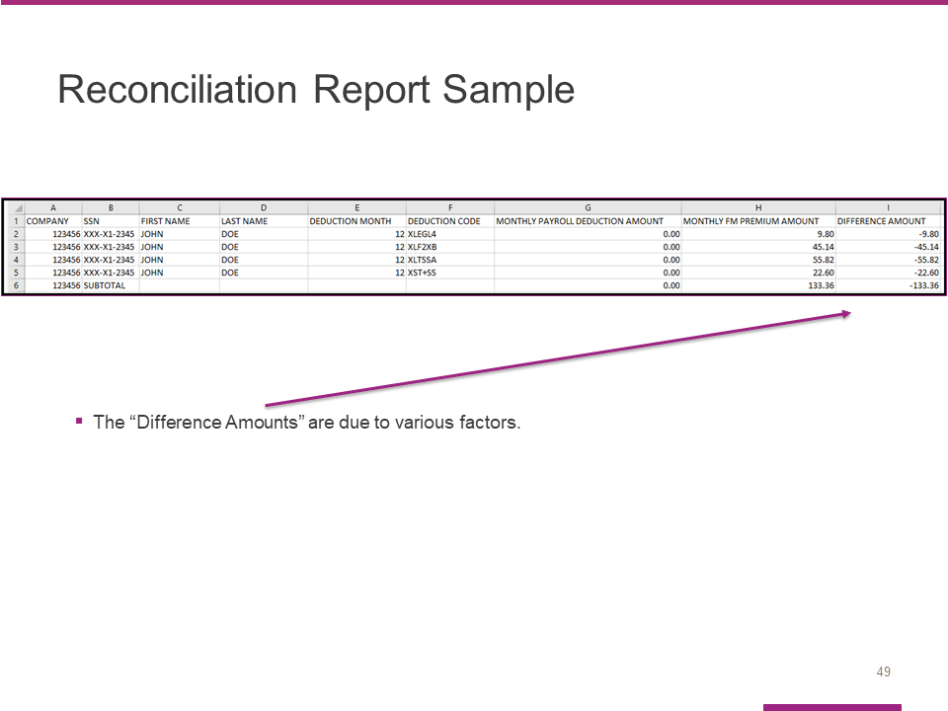

Alight is releasing the new Reconciliation Report this month – May.

To help in your reconciliation, the report will only identify the employees with differences between Alight’s premiums and TeamWorks’ Payroll deductions.

The “Difference Amounts” are due to various factors. The Flexible Benefits Reporting Toolkit (FBRT) training that was held in April provided an overview of the common scenarios and the other reports to reference. If you were not able to attend the FBRT training, or watch the video recording, please do so. If you need information about the FBRT training, please send an email to the Flexible Benefits team at flex.emailsupport@doas.ga.gov.

Slide 50

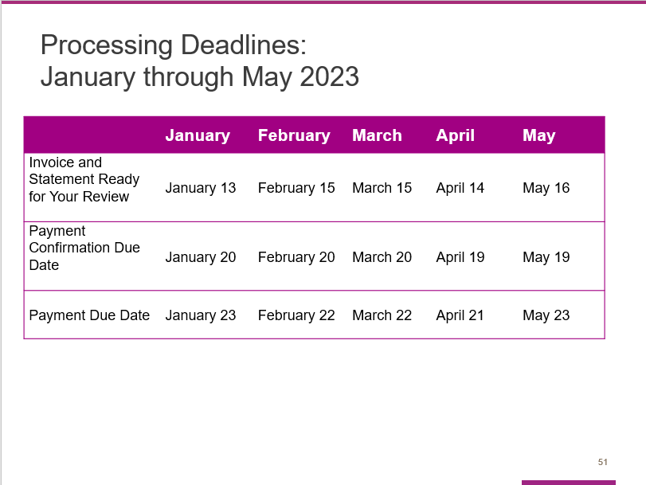

As we wrap up the prepared training program, we want to touch on the project timeline and highlight available resources and support.

Slide 51

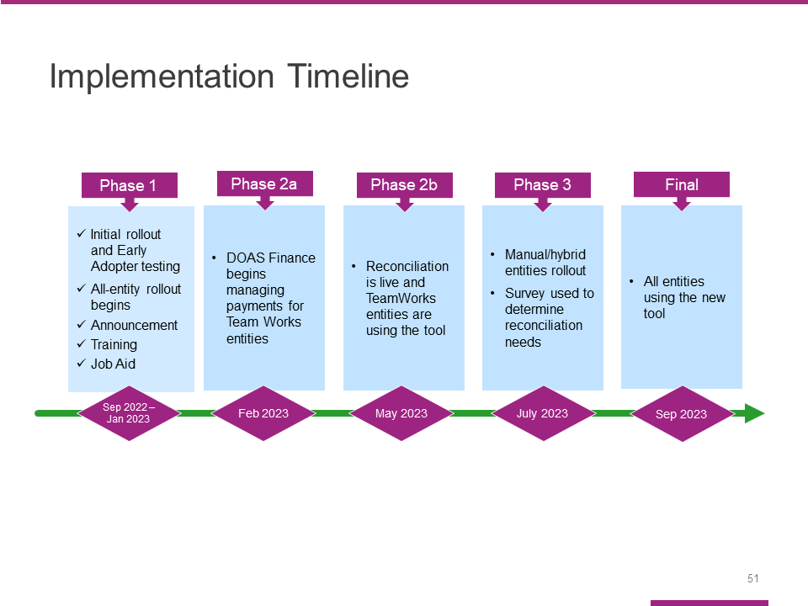

In Phase 2a, DOAS Finance shared the responsibilities with each TeamWorks entity. Your monthly payments were posted to the tool.

In Phase 2b, each entity will access and use the tool. Phase 2b introduces the new Reconciliation report.

Slide 52

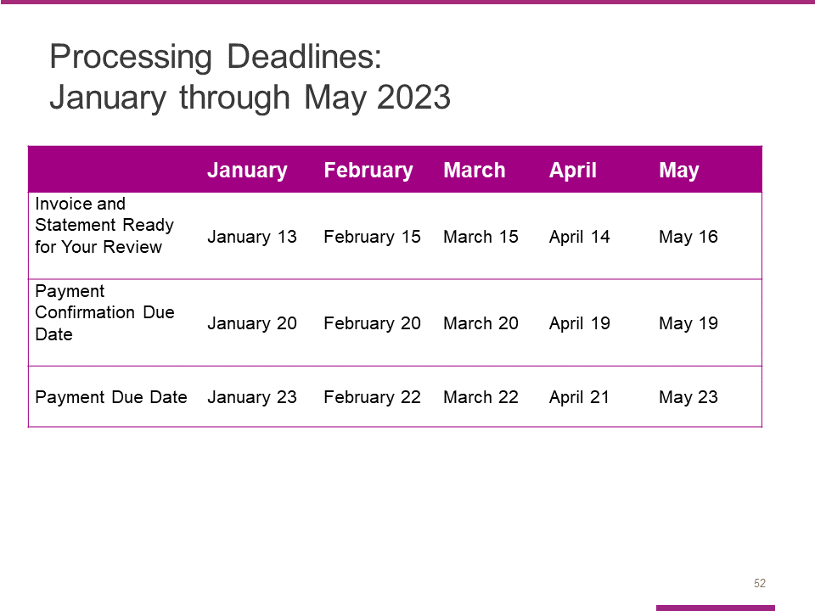

Here are the processing deadlines for the next few months.

Please note, in order to help Alight allocate your payment correctly, confirm your payment in the tool before you send your payment to Alight. If Alight does not receive your payment by the due date, Alight will send an email reminder.

Slide 53

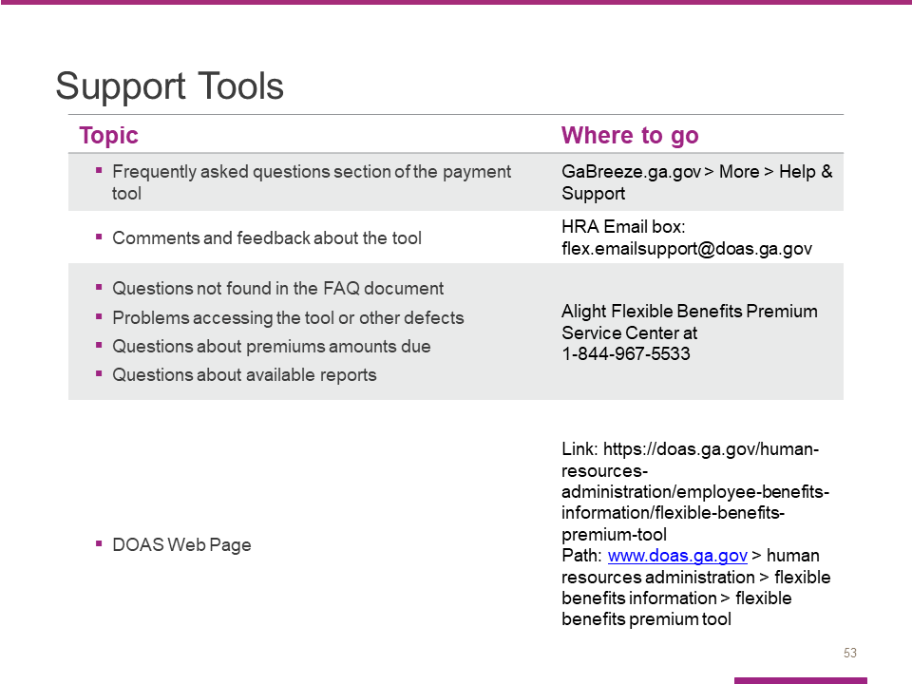

Use these resources if you need help, have questions, or want to provide feedback.
Please note that the FAQs are embedded in the payment tool. There is not a separate document.

Slide 54

Slide 55

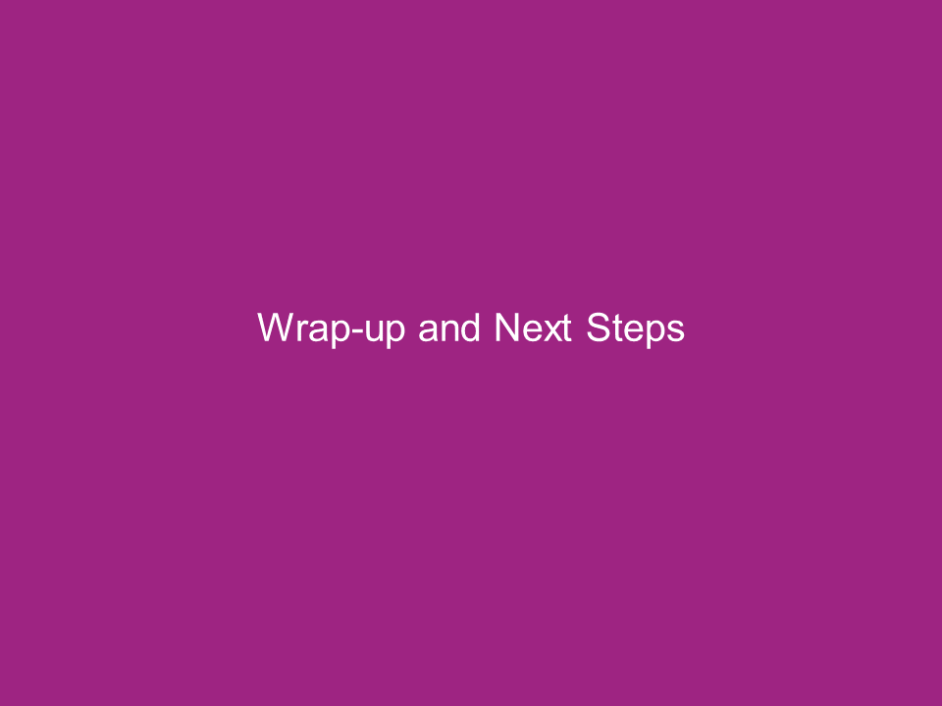

Slide 56

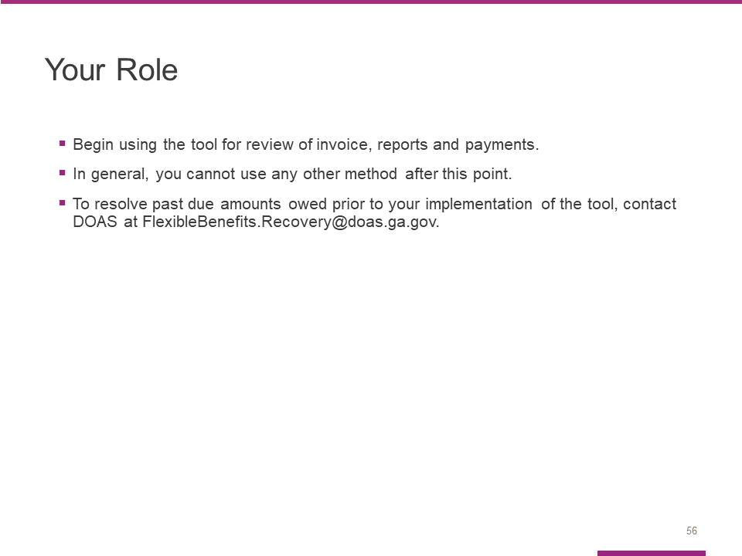

Your Entity is expected to start using this tool after today’s training in May.
In general, you cannot use any other payment methods after today.

To resolve past due amounts owed prior to your implementation of the tool (Feb 2023), contact DOAS at FlexibleBenefits.Recovery@doas.ga.gov.

Slide 57

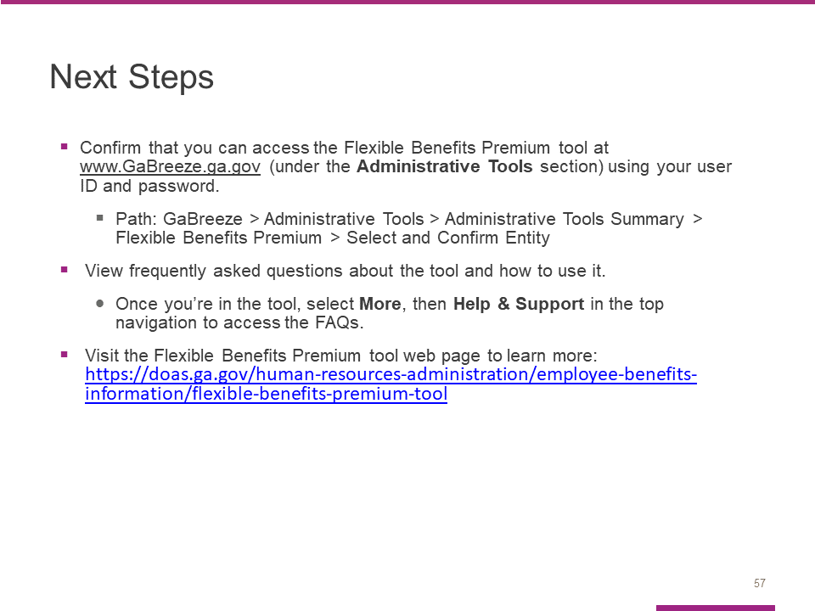

In terms of immediate steps, please take a few minutes to confirm that you can access the Flexible Benefits Premium tool at www.GaBreeze.ga.gov (under the Administrative Tools section).

If you experience technical difficulties, please call Alight at 1-844-967-5533 (located on the Support Tools slide). If you have questions about the tool or this training, contact the Flexible Benefits team at HRA.flexbenefits@doas.ga.gov.

Slide 58

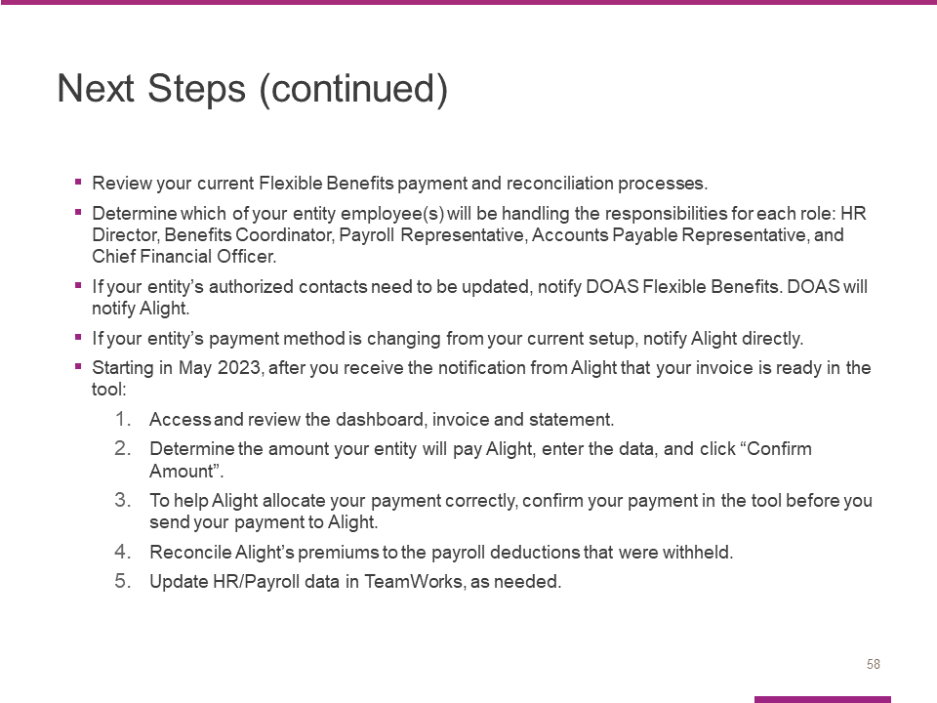

Review your current Flexible Benefits payment and reconciliation processes.
Determine which of your entity employee(s) will be handling the responsibilities for each role: HR Director, Benefits Coordinator, Payroll Representative, Accounts Payable Representative, and Chief Financial Officer.

If your entity’s authorized contacts to access the tool need to be updated, notify DOAS Flexible Benefits. DOAS will notify Alight.

If your entity’s payment method is changing from your current setup, notify Alight directly.

Starting in May 2023, after you receive the notification from Alight that your invoice is ready in the tool:
- Access and review the dashboard, invoice and statement.
- Determine the amount your entity will pay Alight, enter the data, and click “Confirm Amount”.
- To help Alight allocate your payment correctly, confirm your payment in the tool before you send your payment to Alight.
- Reconcile Alight’s premiums to the payroll deductions that were withheld.
- Update HR/Payroll data in TeamWorks, as needed.

Slide 59

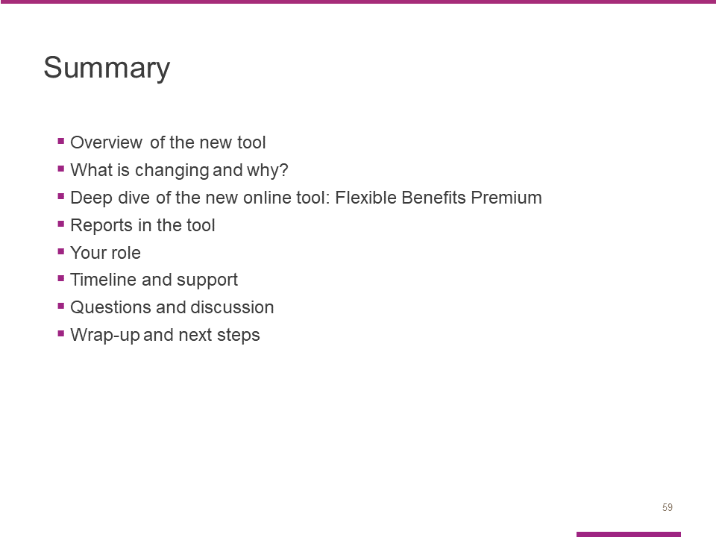

In summary, I presented all the agenda topics.

For TeamWorks entities, you learned about the steps that must be completed each month 1) to make your Flexible Benefits premium payments, and 2) the available tools to reconcile your data.

Slide 60

